

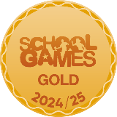
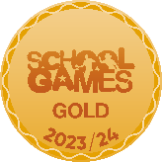


Message from the Principal:

Dear Parents,

I can hardly believe we are at the end of such a busy but very successful year. At this time of year, I always feel extremely proud of all our achievements, from our pupils, especially, but also from our staff and community. Education is at its best when we work with our partners, such as our wonderful parents and our local community.

This year we have had so many fabulous events to take part in, explore, find out about, work together and celebrate!
A highlight for this year has to be our achievement of the School Games Platinum Award, for our extensive and inclusive PE and School sports practise. This also includes well-being and personal development. The values from this programme, and our general ethos are borne out during events such as our super sports afternoon yesterday during which, every single participant was encouraged and cheered by everyone. The difference in time for each event was remarkably small, showing the excellent level of skills development across all ages. You may have seen a link on Dojo to a TV report, recorded this week to celebrate our award. Whilst I really don’t like to see/hear myself on TV I feel it is important to really showcase our school – Miss Skate was reluctant to be on the TV but she really does deserve all the praise for her hard work in leading our team in this area. In addition, we have now had our second year of our Enterprise Project in Key Stage 2, and the children learned some really valuable lessons about market forces, the value of knowing your product and customers alongside learning about finances – great life skills!

I would like to thank you all for your on-going support. I would also like to thank our lovely FOSA group who are always so supportive, and ever-ready with prizes and bags of fun! Attendance at events, parents’ meetings or coming in to discuss any concerns has been very productive. We are always grateful to keep in touch. Look out for more opportunities to join in next year. Thank you for some very kind words, cards and gifts at the end of term.

In the new academic year, we have some changes in staff placement, which offer exciting developments. We are setting up a dedicated classroom, to meet individual needs that cannot be wholly met in classrooms. Our mobile, currently used as a conference room/music room, is being transformed to provide ‘The Orchard’ where children can learn in an environment suited to them. It may be that some children visit just once a week for an additional phonic session, or they might join in with a slower start to school, having breakfast check-ins around the table, or maybe, they will need and enjoy each morning in The Orchard and then each afternoon back with their home class. As time goes by, we will be adding training for staff and will develop more opportunities for our children. We will keep you up to date on the progress of this provision and know that we will all learn and grow with it.

Finally, I would like to wish our Year 6 leavers, every success and happiness as they move on to their chosen secondary school. We have enjoyed seeing how these young people grow and learn throughout the years at Emneth Academy and thank them for their input to our whole school success.

Take care everyone and enjoy a well-earned summer break.

Kind regards, Mrs Huntington

Useful Information
Our school website: https://www.emnethacademy.co.uk/
Another useful link is for the Eastern Multi Academy Trust; you can find out information about the
Trust that we are part of. https://www.eastern-mat.co.uk/
If you would like to contact our Governing Body, please contact the school office and we
will pass on your details for them to contact you.

Attendance Update
A meeting was held this term with the local authority in relation to the Attendance at Emneth, this is something that regularly happens throughout the year.
During the meeting they discuss our Persistent Absences (PA) and the percentage of these within the school. Currently PA is 11.1% which is 23 pupils. This is just below national but something we aim to lower over the next academic year.
‘Late’ arrivals was also discussed. We have had a few meetings in relation to these to see if there is anything we can support with, we will continue to support if needed during the next academic year.
FOSA Update
Thank you everyone for your kind donations for FOSA’s Rainbow Raffle, as always we had so many kind donations, the winning class was Class 3 with their colour GREEN, not only a large quantity but so much variation. Class 3 win a movie afternoon with goodies.
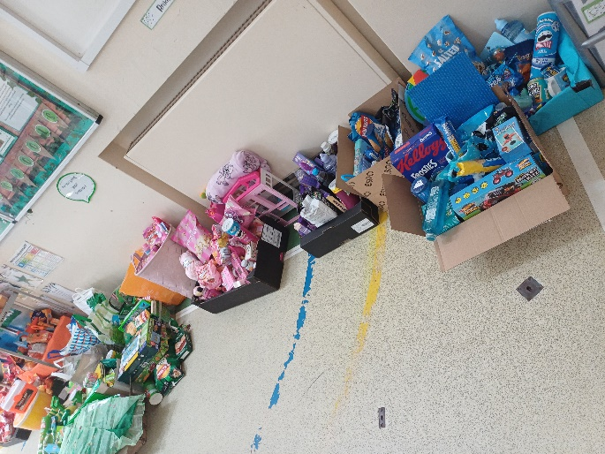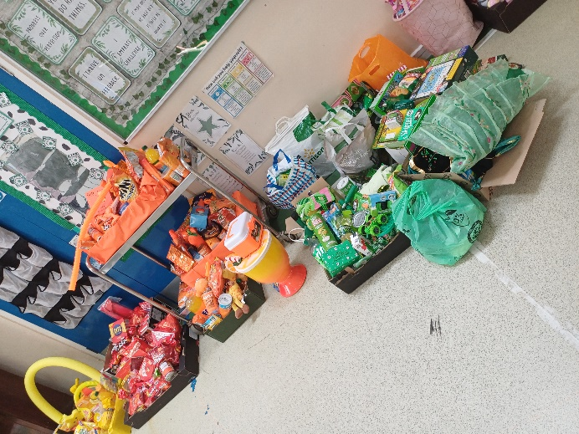

Sports/Art week
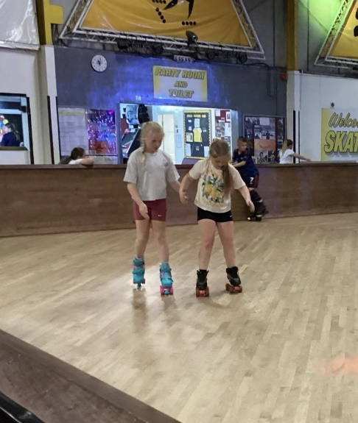
What a whirlwind week we all had, full of creative activities, performances and community spirit. as the school celebrated it’s annual Sports & Arts Week, packing in everything from roller skating, writing poetry, creating installations, to a colour-soaked family colour run. Children had fun on skates, learning a dance routine, learnt about staying safe in water, and had fun with their friends on the field.
Art played just as big a part in the celebrations as sport, with the whole school turning its attention to renowned artist Yayoi Kusama. Inspired by her famous "Obliteration" installation, pupils decorated dotty planters which will take pride of place in the school's sensory garden, bringing a splash of Kusama-inspired colour to the space for years to come. Children contributed to art pieces to be around the school.
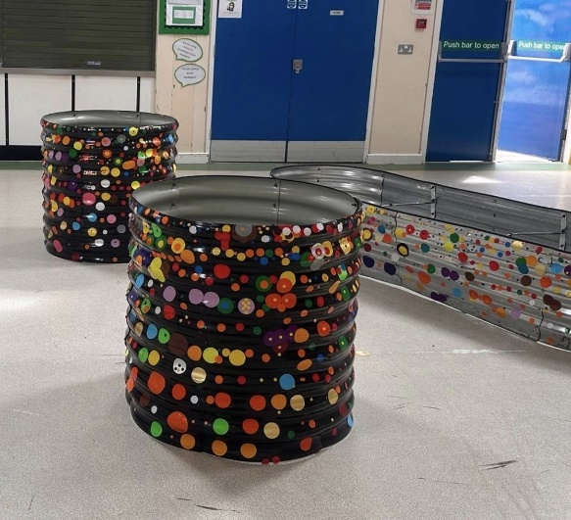
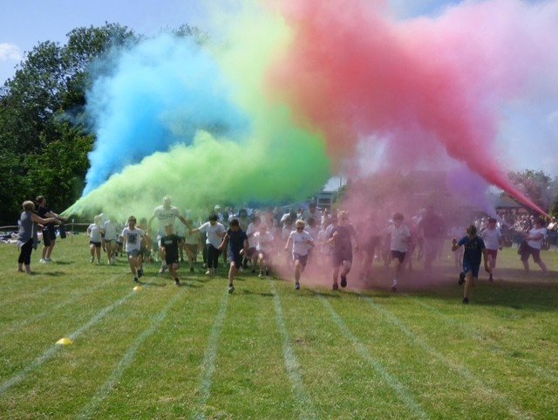
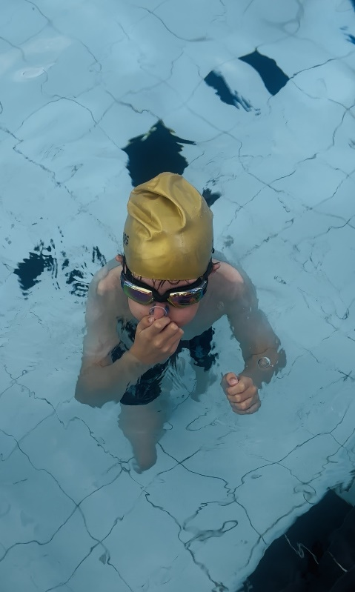

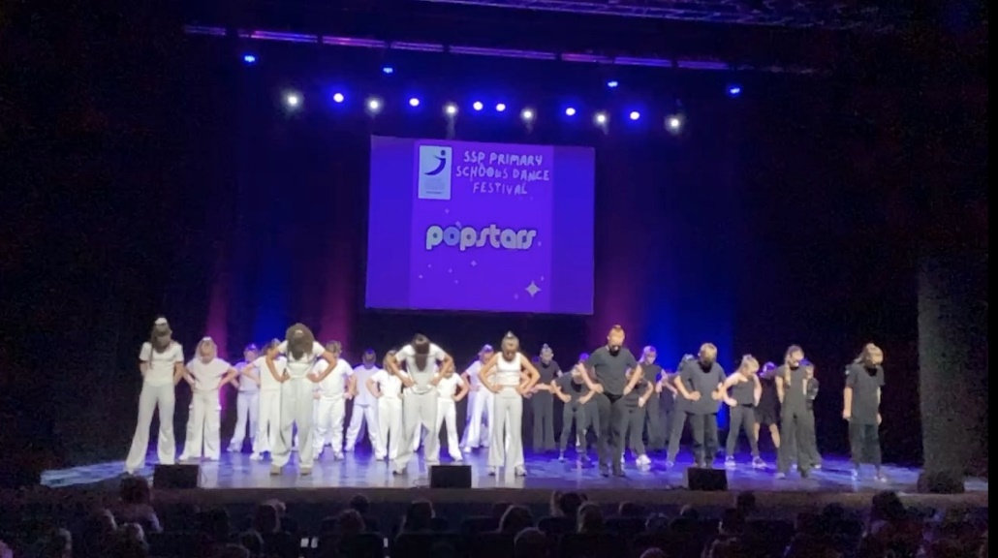

Staffing

YR GROUP/ROLE | STAFF MEMBER | TEACHING ASSISTANT
Executive Head | Elaine Huntington
Deputy Head | Jonathan Parrish
R | Zinnia Baker | Michelle Wye  Tiffany Ward
1 | Jackie Brenchley | Penny Cox  Lorraine Eglen
2 | Lauren Orviss-High  Keeley Fordham (Monday) | Keeley Fordham (AMs)
3 | Alana Sugden | Abbie Young  Keeley Fordham (PMs)
4 | Nicky Hazel | Paula Meredith
5 | Amanda Norman | Chris Robinson
6 | Andy Bazeley -Smith | Kate Barnes
Other | PE – Lynsey Skate
Supporting SEND |  | Lindzi Morgan  Diane Youngs  Sharon Mills

Dates for your Diary 2026/2027
Sept 2026
1st/2nd Sept | INSET Days
3rd Sept | Children back to school
29th Sept | Whole School flu immunisation
Oct 2026
5th Oct | School photos – individuals and siblings
15th Oct | Year 6 Screening – letters to following from Nursing Team
23rd Oct | INSET DAY
21st – 25th | Year 4 bikeability
26th – 30th Oct | Half term
Nov 2026
2nd Nov | Child back in school
24th Nov | Whole school flu immunisation - follow up date
Dec 2026
2nd -4th Dec | Year 6 Residential – Hilltop
18th Dec | Last day at school
21st Dec -1st Jan | Christmas Holidays
Jan 2027
4th Jan | INSET Day
5th Jan | Children back in school
Feb 2027
15th – 19th Feb | Half term
March 2027
26th March | Good Friday – school is closed
26th March – 12th April | School closed
April 2027
12th April | INSET day
13th April | Children back in school
29th April | Year R vision and hearing check. Letter to follow from Nursing team
May 2027
3rd May | Bank Holiday
14th May | School Photos - class
28th May | Last day before half term
31st May -4th June | Half term
June 2027
31st May – 4th June | Half term
7th June | Children back in school

Thank you to you all for making the end of term amazing!
Thank you for the kind words, beautiful cards and very generous gifts.
ENJOY YOUR SUMMER BREAK.

