





I
Message from the Principal:

Dear Parents,

With May almost upon us, we are all preparing for an assessment month. As you are aware, Year 6 will be doing their SATS during week commencing 11th May. It is important that they get to school on time, and to support that, we are once again, providing breakfast for them. Mr B and our FOSA support team are working on this and details will follow.

Assessments will also be undertaken in other years too, so please support us in keeping attendance high and lates, low. Last week, we had a total of 5 and a half hours late last week, so please help us to reduce this. We can help if you have issues at home or with the children, so please do ask us. We are here to help.

Last week our sports group, from Key stage 2, took part in the EMAT sports day at North Wooton Academy…and after a lovely day of great behaviour, our school was awarded Best Team! What an amazing feat – we had some lovely comments too, saying how delightful our children are. I am immensely proud to hear these comments and of our super children.

This week we have said our farewells to Mrs Jenny Hill, our lovely Teaching Assistant, who has been with us for many years working in classes and was instrumental in getting our Forest School Provision up and running. Jenny has decided the time is right for her to take her retirement and we wish her every happiness in doing so. We would like to thank Mrs Hill for her super input to our school – we will miss you!

Mrs Hill’s post will now be taken up by Mrs Abbi Young, who will start her post on 5th May. You may know Mrs Young as a parent of two children at Emneth, but also as a previous volunteer in the school. We are looking forward to working with Mrs Young.

We have some staff off at Southery at the moment, so I am having to change my work patterns. Please do email if you need to raise anything with me, and I will do my best to respond with 48 hours. Thank you for your patience.

Enjoy this lovely weather and take care,

Kind regards, Mrs Huntington

Useful Information
Our school website: https://www.emnethacademy.co.uk/
Another useful link is for the Eastern Multi Academy Trust; you can find out information about the
Trust
that we are part of. https://www.eastern-mat.co.uk/
If you would like to contact our Governing Body, please contact the school office and we
will pass on your details for them to contact you.

Attendance Update
Over all attendance for the Spring term was 95.30%
Class | Attendance
Class R | 92%
Class 1 | 97% 🏆
Class 2 | 94%
Class 3 | 96%
Class 4 | 94%
Class 5 | 94%
Class 6 | 96%
🏆 Attendance Winner for Spring Term Class 1 (97%) Well done.

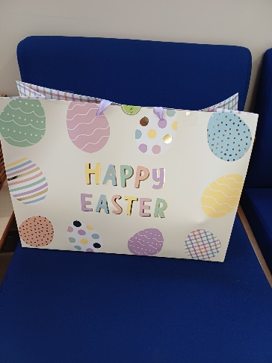
FOSA Update
Every child was given an Easter Egg at the end of term by FOSA.
They also gave 3 prizes for the Easter Bonnet Parade at the Church.
Well done to our winners in KS1.
Class R Fred
Class 1 Pheobe
Class 2 Honey
French Café
Emneth Academy's first French café was a wonderful success and a highlight of the term. The school hall was transformed into a charming café, giving pupils a real taste of French culture while providing a fun and meaningful way to practise using French in a real-life context. Children confidently ordered food and drinks in French, impressing staff with their growing language skills. The event played an important role in raising the profile of Modern Foreign Languages (MFL) across the school and clearly boosted pupils’ confidence. A special mention goes to our Year 6 pupils, who took on the roles of waiters and waitresses with enthusiasm and maturity, demonstrating excellent leadership and teamwork throughout. It was a thoroughly enjoyable experience for everyone involved and a fantastic celebration of language learning. Thank you so much to FOSA for providing the pastries and drinks for the event, it is so much appreciated!
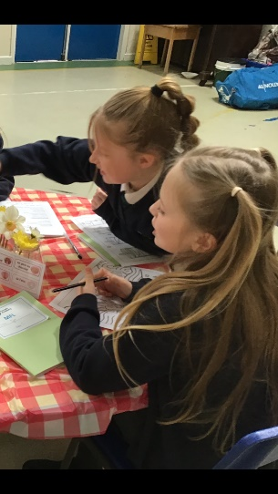


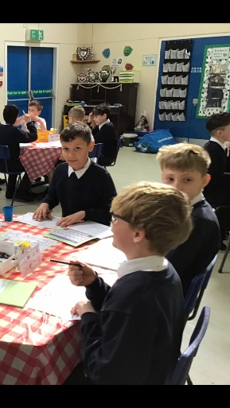

Personal Items brought into school
We kindly ask for your support in ensuring that children do not bring personal items into school.
Unfortunately, personal belongings such as toys or special items can easily become lost or damaged during the school day, and we are unable to take responsibility for them. To help avoid any upset or distress, we respectfully request that children leave personal items at home unless otherwise instructed by the school. Thank you for your understanding and cooperation.

Dates for your Diary

April
13th April | INSET day for staff – School closed for children
14th April | Children back in school
14th April | FOSA pre-loved uniform sale
16th April | FOSA non uniform day – gift donations of £1 please towards events (NB also World PJ Day!!)
17th April | Closing date for Governor nominations
29th April | Class 4 - Pizza workshop
May
4th May | Bank Holiday
5th May | FOSA Clothes throw
w/c 11th May | Year 6 SATS week
12th May | FOSA pre-loved unform sale
15th May | Group Photos
19th May | Olly Day – Year 3 and Year 4 Road Safety Magician
20th May | National numeracy day
22nd May | FOSA pocket money shop 3.15
22nd May | Last Day at school – Break up at 3.15pm
25th – 29th May | Half term
June
1st June | Children back in school
2nd June | Year R and Year 6 checks
4th June | New Intake evening 4.30
5th June | FOSA non uniform day – Rainbow raffle – details to follow.
15th June | Whole School Sports Event – Skaters – Details to follow
16th June | SSP Dance Show
16th June | PM Year 6 swimming
16th June | Class 4 Asian Workshop
17th June | SPORTS DAY – 9.30 KS2, 1.30 KS1 – Details to follow
19th June | 2.00 pm Colour Run – Details to follow
23rd June | New intake Stay and Play
July
1st July | New intake stay and play
2nd July | St Clements High Year 6 transition Day
7th July | St Clements High Year 5 Taster Day
14th July | New intake stay and play
17th July | Leavers’ Assembly 1.45 – 2.45 – details to follow
17th July | Last day of school – Break up at 3.15
20th July | INSET – training day for staff – School closed for children

Sept 2026
1st/2nd Sept | INSET Days
3rd Sept | Children back to school
25th Sept | Whole School flu immunisation
Nov 2026
24th Nov | Whole school flu immunisation - follow up

