





I
Message from the Principal:

Dear Parents,
s,
Warm greetings to each of you — I hope this message finds your family well and enjoying the season. We are grateful for your continued partnership and the kindness you show our school community each day.
As we go into our final week this term and this year, we say a fond farewell to a year of some amazing activities, long-term learning and terrific teamwork!
Recent excitement came with:
- Our Rudoph Run - A super event enjoyed by many children. Thank you in particular to Mrs Fordham for her super organisation and drive, and to everyone who helped support and cheer our runners on.
-Two amazing performances from KS1 and EYFS — the children performed beautifully and families’ support made them extra special. (We look forward to the Church service for KS2 pupils this week.)
- Year 6 residential: A very successful trip to Hilltop Outdoor Centre. Our Year 6 pupils showed bravery, teamwork, and enthusiasm — it was a fantastic experience, and once again the children were an absolute credit to themselves, you as parents and us as a school.
- The children’s kitchen has been sending out delightful aromas as the children have been learning about baking and have created some fabulous culinary delights! Thank you to Mrs Francis who has been in such a lot to help the children. I also enjoyed a mince pie and a hot chocolate made by the children!
I would like to send a special thankyou to the FOSA committee for their hard work and dedication. Their efforts, supported by you our parent body, and our staff, make a real difference to our school and our children’s experiences.
Our plans for the new year are exciting and include a complete refurbishment of our library system. We are so looking forward to bringing about some positive changes and encouraging a love of reading to support our children’s learning for a lifetime. We will also be doing some re-structuring of our internal spaces to provide more break out space for children. Watch this space for photographic progress!
I would like to say a huge thanks to our hardworking, dedicated, and very kind staff who give over and above what is asked of them day in, day out. We also thank our lovely children, who come in each day ready and eager to learn and who put a smile on anyone’s face, whatever the weather!
We are grateful for your ongoing partnership and the many ways you support our school community. Together we create a warm, safe, and inspiring place for our children to grow. We look forward to continuing our work with you and to many more happy moments ahead.

I wish you all a safe, restful and joyous festive time.
With very best Christmas wishes,

Kind regards,
Mrs Huntington

Reindeer Run
Children and staff had an amazing afternoon, the children ran around the course to earn their antlers to help save Christmas, we even had a little snow to add to the atmosphere.
Thank you all so much for donating to this local charity, w have collected over £1750 – Amazing!
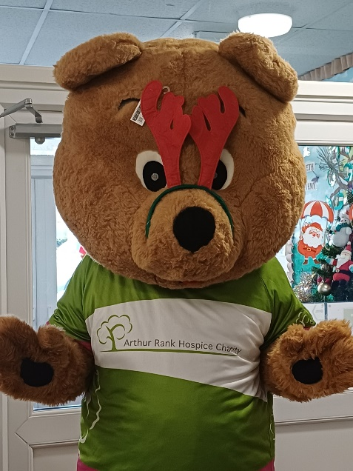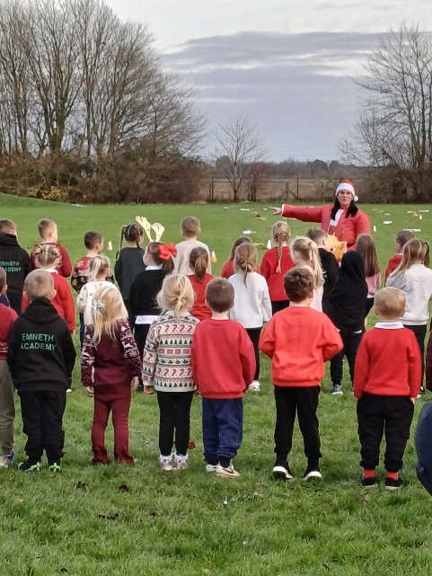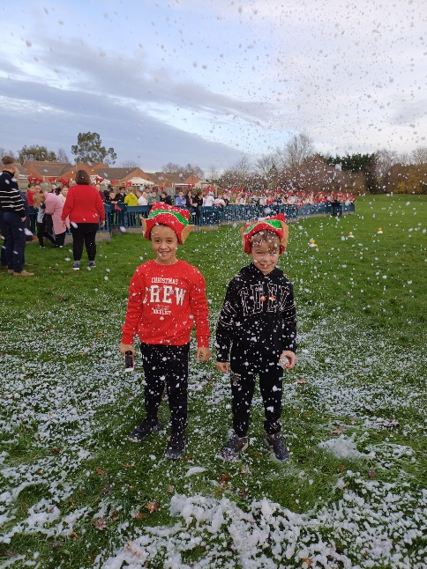
Attendance Update
Attendance for the Autumn Term is 95.5% and our Persistent absence is 11.1%
Year R 91.6%
Year 1 96.4%
Year 2 95.2%
Year 3 96.8% Well done Year 3, Keep it up!
Year 4 95%
Year 5 94.6%
Year 6 95.8%
We have been sent figures from the Trust and the Department of Education who constantly monitor every schools attendance figure.
At the end of this term we are in line with the Trust Academies and are sitting at 125 out of 342 within our local authority.
FOSA Update

Advent raffle winners.
What beautiful advent calendars, tickets were drawn on Friday 28th November.
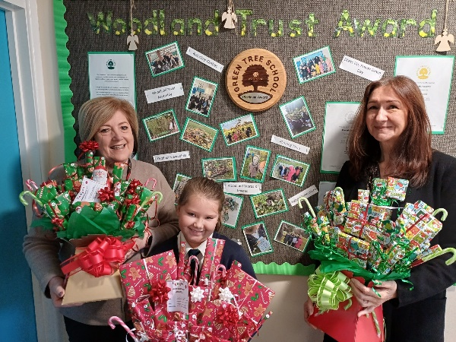
Bags2School
Thank you to every brought in bags for our Bags2School, we raised just over £122.

School Disco
It’s always lovely to see so many children enjoying themselves at the school disco. With the sale of the tickets and pocket money shop they took over £400. Thank to everyone who came to help and to FOSA for arranging it all.

Dates for your Diary
December
16th Dec | Class 3,4,5,6 Carol concert at the Church 1.45 – 2.45 pm
18th Dec | Christmas Lunch - Menu on Select please order as normal
18th Dec | Children can wear Christmas Jumpers (NO money collection but feel free to make your own donations on line to this charity)
19th Dec | Last Day before Christmas Holidays -Break up at 3.15pm
January 2026
5th Jan | INSET day
6th Jan | Back to School
12th Jan | Class 5 Game Changers
19th Jan | Class 5 Game Changers
26th Jan | Active Kids
February
2nd Feb | FOSA event
9th Feb | Year 5 Game Changers
12th Feb | Starlincs – class 2 and 5
16th – 20th Feb | Half term – Break up at 3.15pm
March
2nd March | Year 4 Healthy Body Healthy Mind
5th March | World Book Day
9th March | Class 4 Healthy Body Healthy Mind
11th March | Class 4 Pizza Workshop
16th March | Healthy Body and Healthy Mind
25th March | Class 6 Health Screening
25th March | Class R Health Screening
27th March | Last Day of school – Break up at 3.15pm
30th Mar – 13th April | Easter holidays
April
13th April | INSET day
14th April | Children back in school
May
4th May | Bank Holiday
w/c 11th May | Year 6 SATS
15th May | Group Photos
22nd May | Last Day at school – Break up at 3.15pm
25th – 29th May | Half term
June
1st June | Children back in school
16th June | Class 4 Asian Workshop
July
17th July | Last day of school – Break up at 3.15
20th July | INSET – training day for staff – School closed for children


Useful Information
Our school website: https://www.emnethacademy.co.uk/
Another useful link is for the Eastern Multi Academy Trust; you can find out information about the Trust
that we are part of. https://www.eastern-mat.co.uk/
If you would like to contact our Governing Body, please contact the school office and we
will pass on your details for them to contact you.

