 |  |  | EMNETH ACADEMY LONG TERM PLAN
Subject |  |  | English Writing
Leader |  |  | Jonathan Parrish
ACADEMIC YEAR |  |  | 2025 - 2026
Year  Group | Autumn 1 | Autumn 2 |  | Spring 1 | Spring 2 | Summer 1 | Summer 2
R | Introducing  language | We’re Going on a Bear Hunt  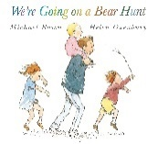  (Narrative) |  | Chocolate Mug Cake (Instructions)  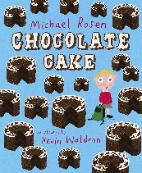  Rosie’s Walk (Narrative)  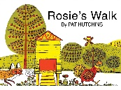 |  | Where the Wild Things Are  (Narrative)  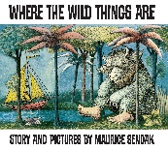  If Sharks Disappeared (Report)  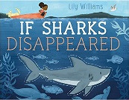
1 | The Train Ride (Narrative)  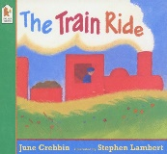  Our Trip to the Woods (Recount)  Firework Night (Poetry) |  |  | Seasons (Information Text)  The Queen’s Hat (Narrative)  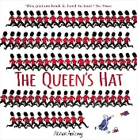 |  | Pinocchio  (Narrative)  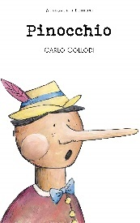  Little Red Riding Hood (Narrative)  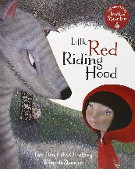
2 | The Owl who was Afraid of the Dark (Narrative)  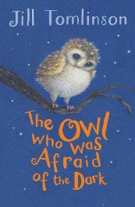  The Day the Crayons Quit  (Persuasive letter)  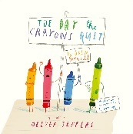 |  |  | Desk Diddler  (Poetry)  The Crows Tale (Narrative)  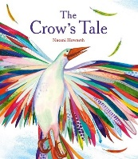  Hibernation  (Non-chronological Report)  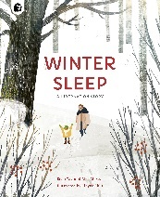 |  | George and the Dragon  (Narrative)  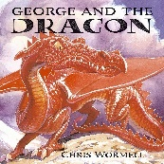  If I were in charge of the World  (Poetry)
3 | The Incredible Book Eating Boy  (Narrative)  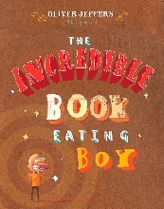  Autumn is here (Poetry)  The Journal of Iliona (Diary)  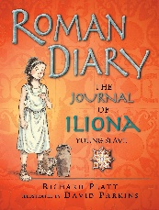 |  |  | Stone Age Boy (Narrative)  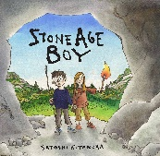  Earthquake  (Non-chronological Report)  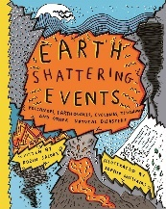  Wolves in the Walls (Narrative)  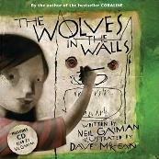 |  | I asked the little boy who couldn’t see (Poetry)  Street Beneath my Feet  (Explanation)  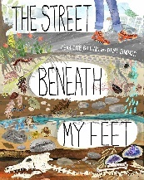  Theseus and the Minotaur  (Narrative)  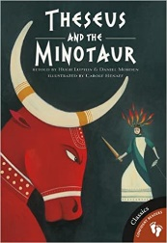
4 | The Iron Man (Narrative)  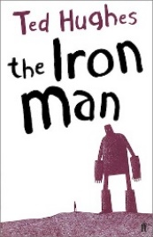  Still I Rise  (Poetry)  The Creature (Journalistic) |  |  | Charlie and the Chocolate Factory (Narrative)  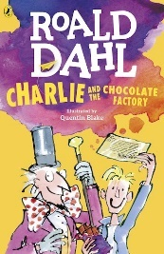  Should we feed animals at National Parks?  (Balanced Argument)  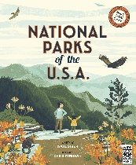  Sicily Holiday Brochure  (Persuasive) |  | The Lost Thing (Narrative)  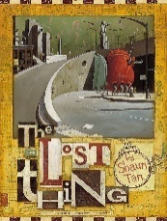  Once upon a raindrop  (Script for factual tour)  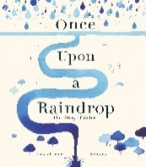  The Plague (Playscript)
5 | The Explorer (Narrative)  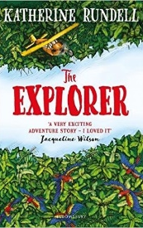  The Malfeasance (Poetry)  The Snowman (Narrative)  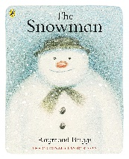 |  |  | David Attenborough (Biography)  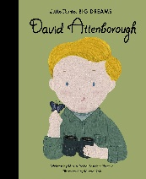  Gorilla  (Narrative)  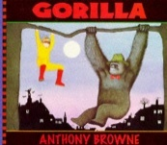 |  | The Highwayman (Poetry)  Emperor Penguins (Non-Chronological Report)  Refugees  (Speech)
6 | Varmints  (Narrative)  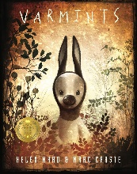  Goldilocks (Journalisitc)  Everest  (Non-chronological report)  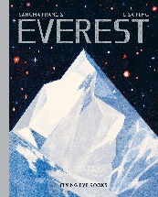  Goldilocks and the Three Bears (Postcard/Informal) |  |  | Kensuke’s Kingdom (Narrative)  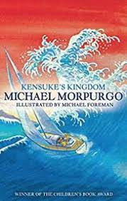  Thinkers Rap  (Poetry)  The Journey  (Narrative)  Greta Thunberg  (Persuasive Information Speech) |  | Charles Darwin Origin of Species  (Non-chronological Report)  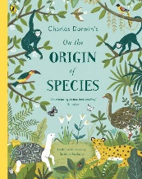  Narrative Poem(Narrative poem)

