





I
Message from the Principal:

Dear Parents and Carers,

Well done to you all for moving confidently through an intense assessment period and particularly to Y6 for their resilience. After half term, our assessments will continue for our younger pupils; we have the phonic checks and KS1 SATs taking place in June, for Year 1 and 2 pupils, Year 4 pupils will do their multiplication checks on line and we will be writing the Pupil Annual Reports for all children at the end of June. These reports will be sent out to parents, electronically, as in past years.

It is really important that we continue to maintain our super attendance with relatively few latecomers, particularly when they have an assessment due. A prompt start to the day means that the children can all join in their class routines together and have access to all the preparation and encouragement we can give. Whilst I understand that sometimes, absences during the term are unavoidable, please understand that children will miss out on important learning if they have extended periods away from school, for holidays. I have no doubt they will have fabulous experiences, and I agree, family time and holidays are so important. However, there are lots of ways to enjoy family time during school holidays, and keep your children coming to school each day. I have seen so many children return from a holiday this year and take a couple of weeks, to get back into routines etc and this does take learning time, to get back up to where they were before the break. I am passionate about all children achieving their very best and find it upsetting to see children struggling socially, or missing out routines, or a specific piece of learning as they have been off school. I have a duty of care to all children, and the staff, so please understand we are here to work with you to support you in whatever way we can. Do complete an absence form if you are planning a holiday and please continue to be up front about this. If you only have one holiday absence in a child’s education here, we may authorize that, as it is exceptional. If it happens every year, it isn’t exceptional so I am unable to authorize.

Mr Parrish and I conducted a learning walk and a book scrutiny this week and have been so impressed with the standards we are seeing, with the progress and the evidential pride that children take in producing their work. Your support for this, and seeing them happily into school each day is a huge part of their success. We are particularly proud of how well our pupils with additional needs are given access to the curriculum and of the high expectations our children are rising to, every day. I am sure you will all share in the pride we feel when we see our children behaving well, trying their hardest, supporting each other and being successful. In a world where this is not always the case, we should all take time to be grateful for what we have. Enjoy your half term.
Kind regards, Mrs Huntington

Useful Information
Our school website: https://www.emnethacademy.co.uk/
Another useful link is for the Eastern Multi Academy Trust; you can find out information about the Trust
that we are part of. https://www.eastern-mat.co.uk/
If you would like to contact our Governing Body, please contact the school office and we
will pass on your details for them to contact you.

Art Competition - Worzals
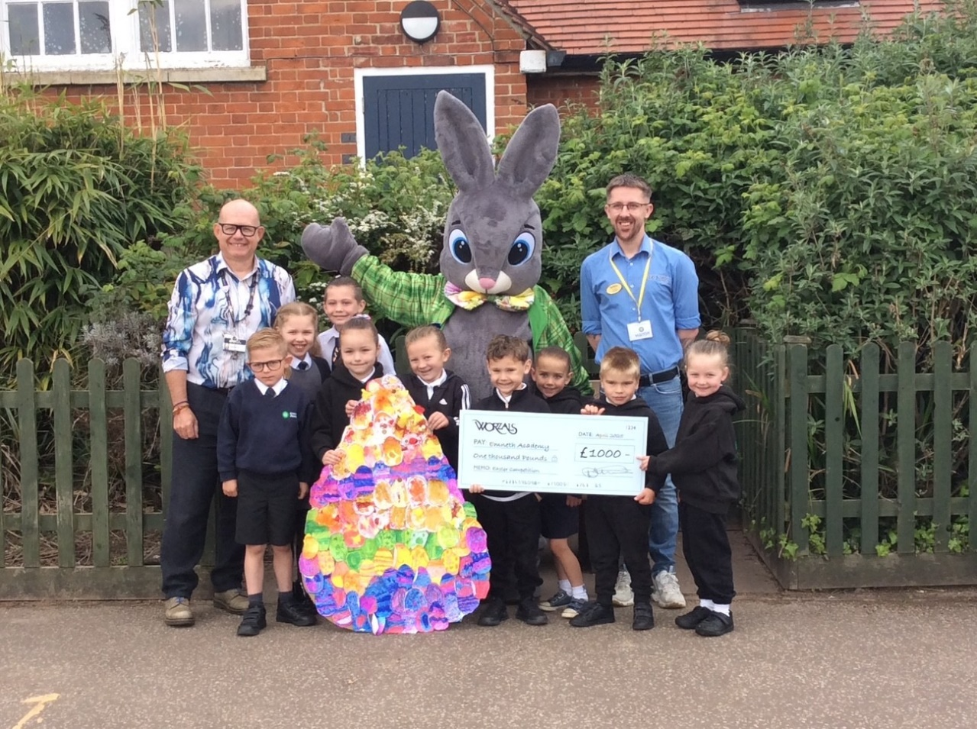

Well done KS1 for winning the Worzals’ Easter Competition; we had a lovely visitor come into school to present the children with prize, a cheque for £1,000! We will keep you informed what we have purchased for the school.
We hope KS1 children had a fantastic time on their visit, if you managed to go.

Layer Up Power Down Day
On 1st April we held our Layer Up Power Down Day. Total spend on energy for that day was £25.28 on Gas and £41.26 pm Electricity, total for the day was £66.54. The day before our spend for energy was £72.96 on Gas and £52.49 on electricity. The total for the day being £125.45, Many thanks for your support as always.
With your help we made a massive savings of £58.91 in one day

Attendance - update
Emails were sent to parents with an update on their child’s attendance. Any update to your child’s attendance that we wish to make you aware off, or wish to discuss, will be communicated via email. If you would like an update for your child’s % at any time, please do not hesitate to contact the office.
April 2025
Class R | 93%
Class 1 | 91%
Class 2 | 96%
Class 3 | 97%
Class 4 | 92%
Class 5 | 97%
Class 6 | 98%

Well done Class 6!

FOSA – Update
Winners

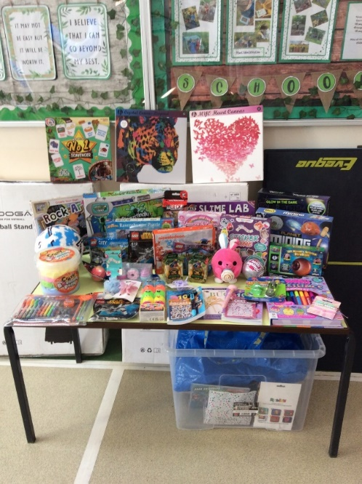
Thank you to everyone who took part. Winners are.
Draught Excluder – Year R Joshua, Year 2 Carter, Year 5 Elida, Year 6 Isobelle
Pin Wheels – Year R Jacob Year 1 Aranea, Year 2 Roma, Year 3 Ronnie, Year 5 Olivia, Year 6 Caroline
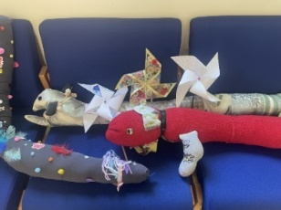
Biscuit decorating – Year R Ayla, Year 1 Evie, Year 2 Blysse, Year 3 Taya, Year 4 Eli, Year 5 Kasia, Year 6 Caroline.

Wonky Bars
Winners of ‘working in the office’ - The Admin Team would like to thank Jenson, Ayden, Phoebe and Aiden for coming and helping in the office. We thoroughly enjoyed having the children in the office with us, they were a great help, we hope they enjoyed their time with us.
SATS Breakfast
The school would like to thank FOSA for arranging the SATS breakfast for the Year 6 Children. We would like to send a massive thank you to Emneth Spar Shop and Asda for supplying the items. Thank you so much, it makes such a difference to the children to be able to come into school earlier, have breakfast with their friends before the SATS.

If you have any unwanted Christmas gifts that FOSA could use for raffle, bingo or Tombola prizes, please feel free to drop them into the Academy Office.

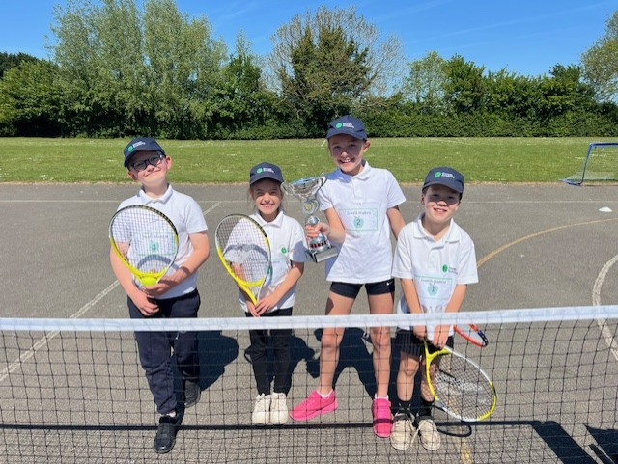
Sports Round Up - May 2025
Tennis Competition
I would like to congratulate our Y3/Y4 Tennis team, who were recently crowned the overall winners of the Marshland St James Cluster Tennis Competition. It was fantastic to see the team demonstrate a wide range of net and walk skills, fantastic sportsmanship and awesome teamwork.

Summer Term PE
The summer term is upon us, we’re really enjoying being able to access our PE lessons in the sunshine. The children are fully focused on the Athletics and Games units of study. Tennis, Dodgeball and Rounders are proving to be favourites.
We’re making good use of the running track and are working hard, preparing for Sports Day 2025. I cannot wait for you to see the children participate in a wide range of exciting races.

Swimming
Our Y5 children are coming to the end of their swimming lessons. It’s fantastic to see all of the progress the children are making.
Our Y6 children start their swimming lessons on Tuesday 10th June.
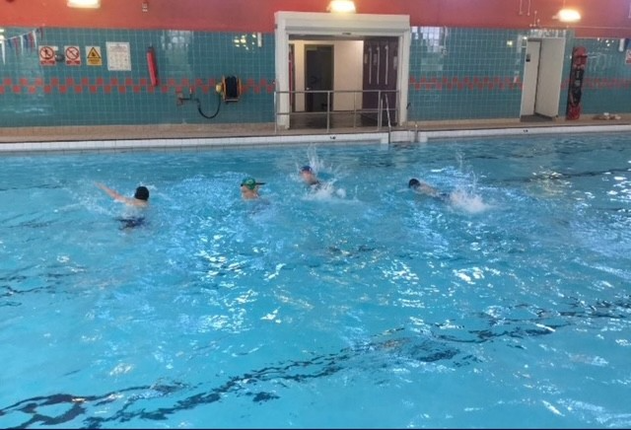
Do you know what the government swimming targets are ?
They would like all children, by the age of 11 years, to be able to swim at least 25 meters. They would also like the children to demonstrate a wide range of swimming strokes and to be able to perform swimming safety skills.
Our Y5/Y6 school swimming lessons help assist the children to reach these targets.

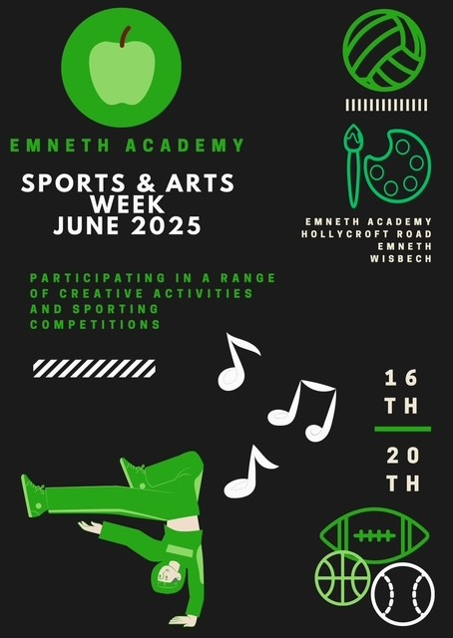
Sports/Art Week 2025
We normally hold an EMA Sports Week (16th -20th June), this year we’re shaking things up! Mr B and I are blending Sport and Art together. Lots of fun, creative, sporty activities are planned for the children, staff and parents to complete over the week.
Watch this space, more info to follow….

Dates for your Diary
May
1st May | Crucial Crew Year 6
1st May | Year 5 Gressenhall
5th May | Bank Holiday
12th May | KS2 SATS all week
16th May | Class photos
21st May | National numeracy day
23rd May | Professor Pancake Assembly – Funded Fully by FOSA
23rd May | Non Uniform Day
26th May | Half term
June
2nd June | Children back in school
2nd – 13th June | Year 4 Multiplication table checks
2nd – 13th June | Year 2 SATs
9th – 13th June | Yer 1 Phonics
16th June | Sports event - further information to follow
17th June | Dance Festival – details to follow
18th June | Sports Day – KS2 AM and KS1 PM – Details and times to follow
30th June | Circus – FOSA event – tickets on sale
July
1st July | Circus Workshops – whole school
7th July | Year R Church Farm
8th July | Year 6 Transition Day to Downham Market
9th July | Year 6 transition Day to Downham Market
10th July | Parents evening at MHS for new Year 7
11th July | Transition Day at MHS for Year 6
11th July | Jump up day
17th July | Year 5 Taster Day MHS
18th July | FOSA bingo
22nd July | Last day of term

