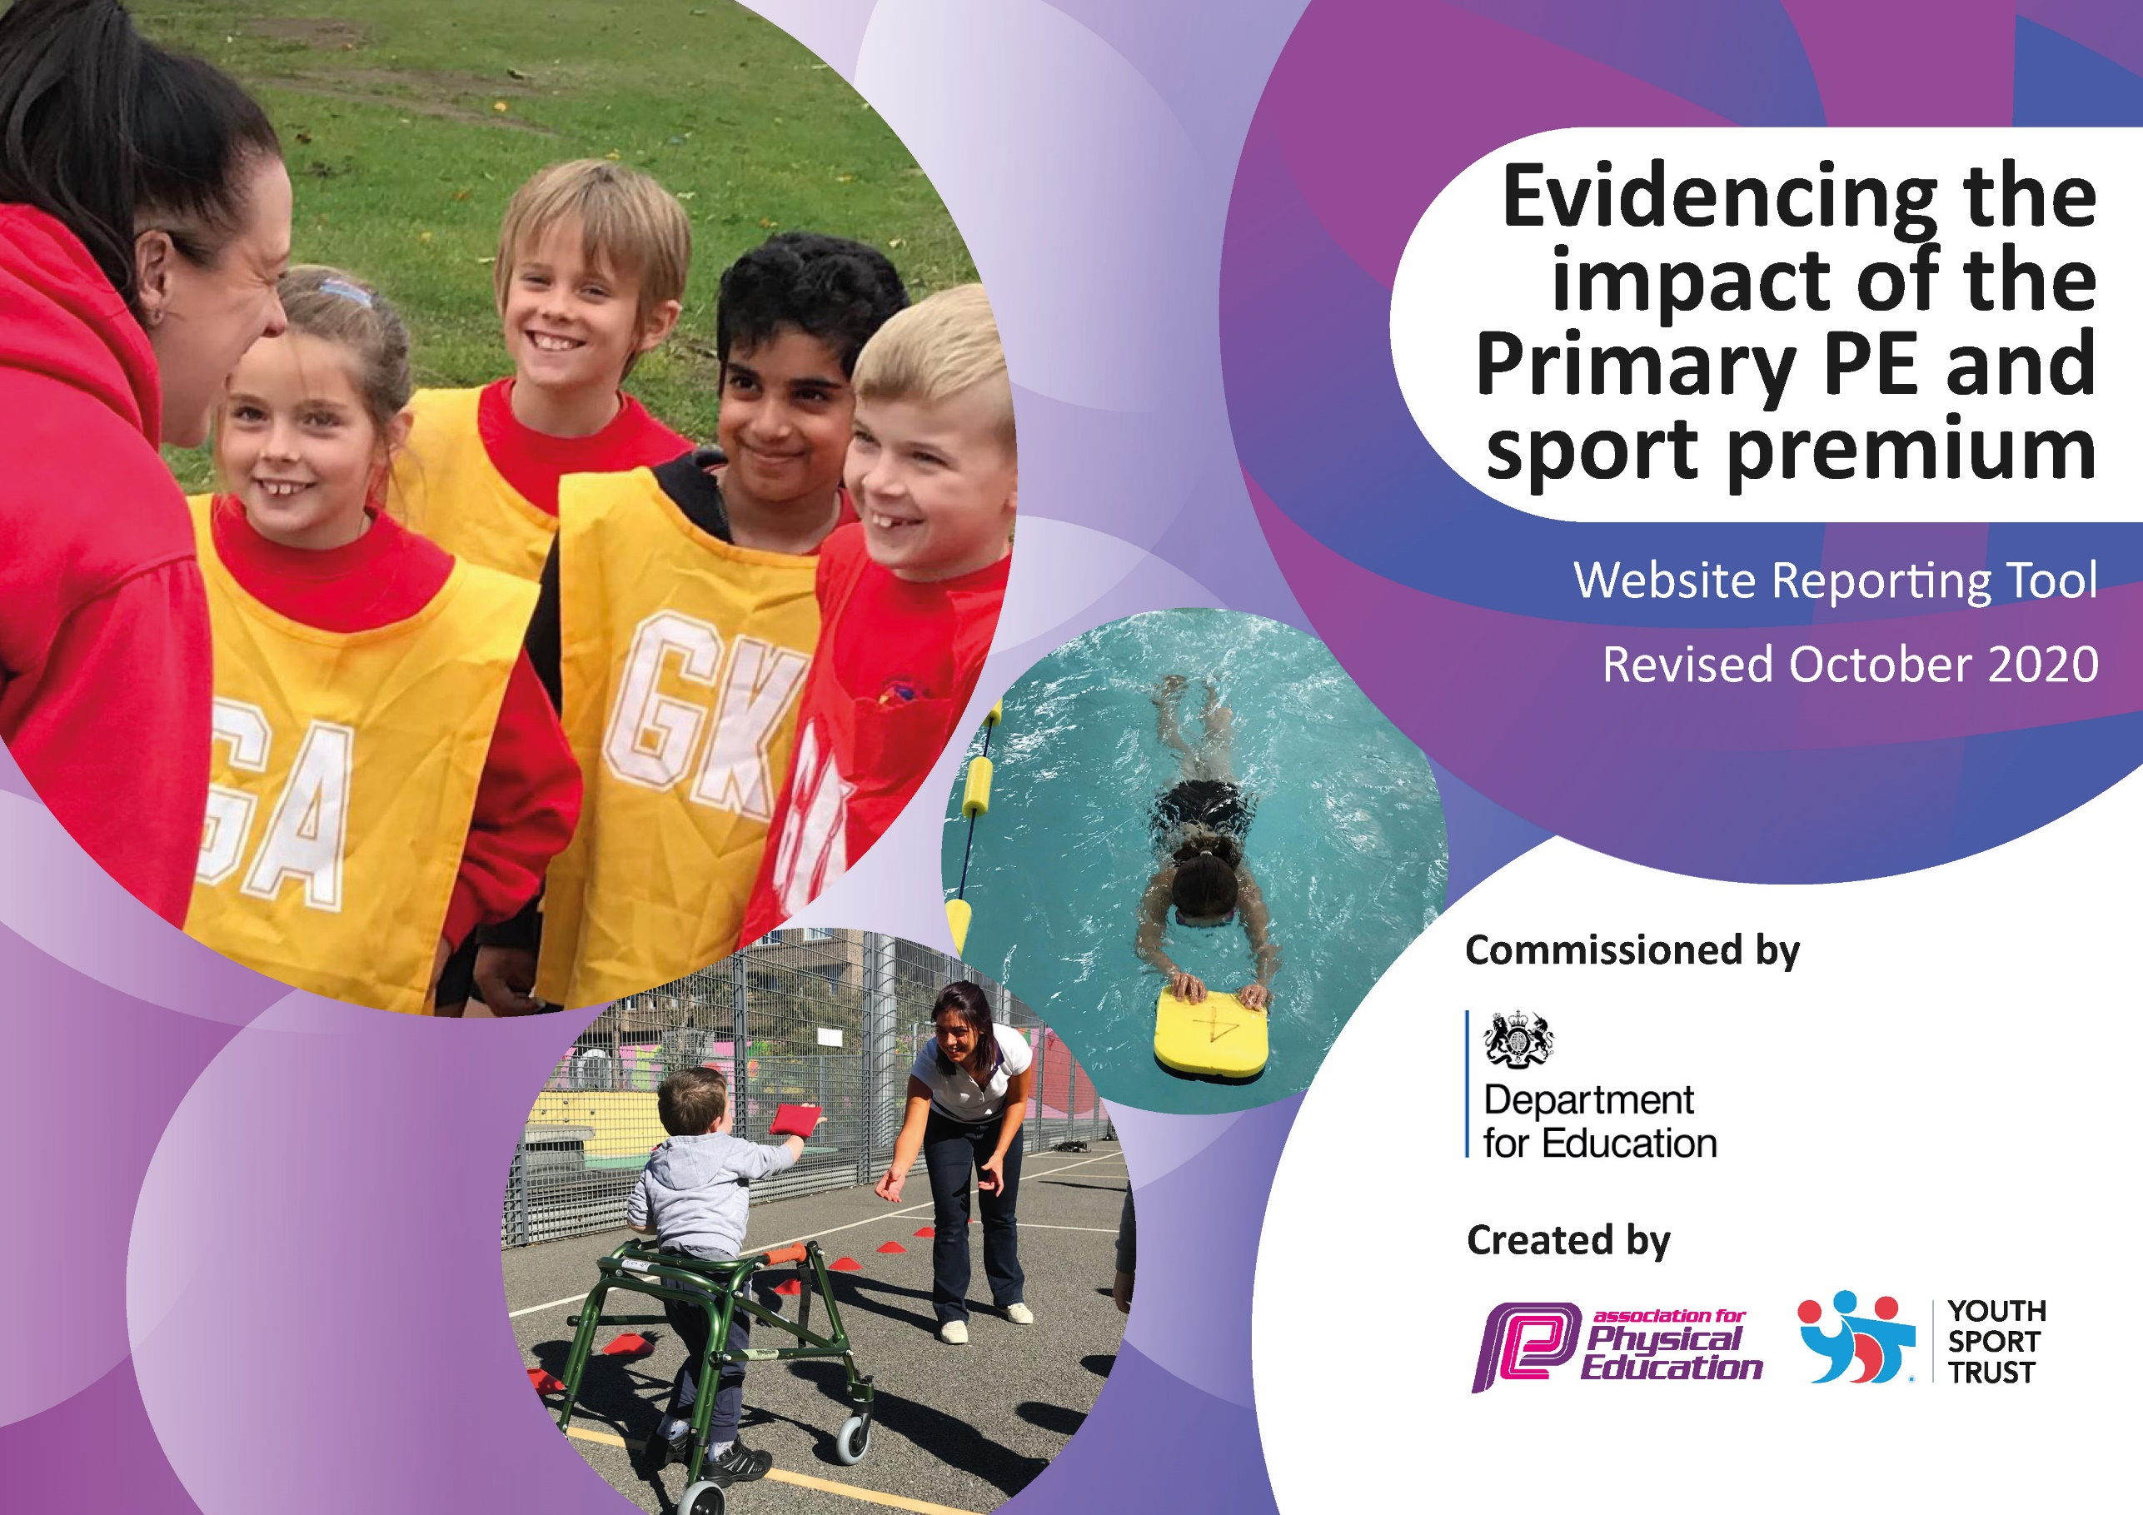
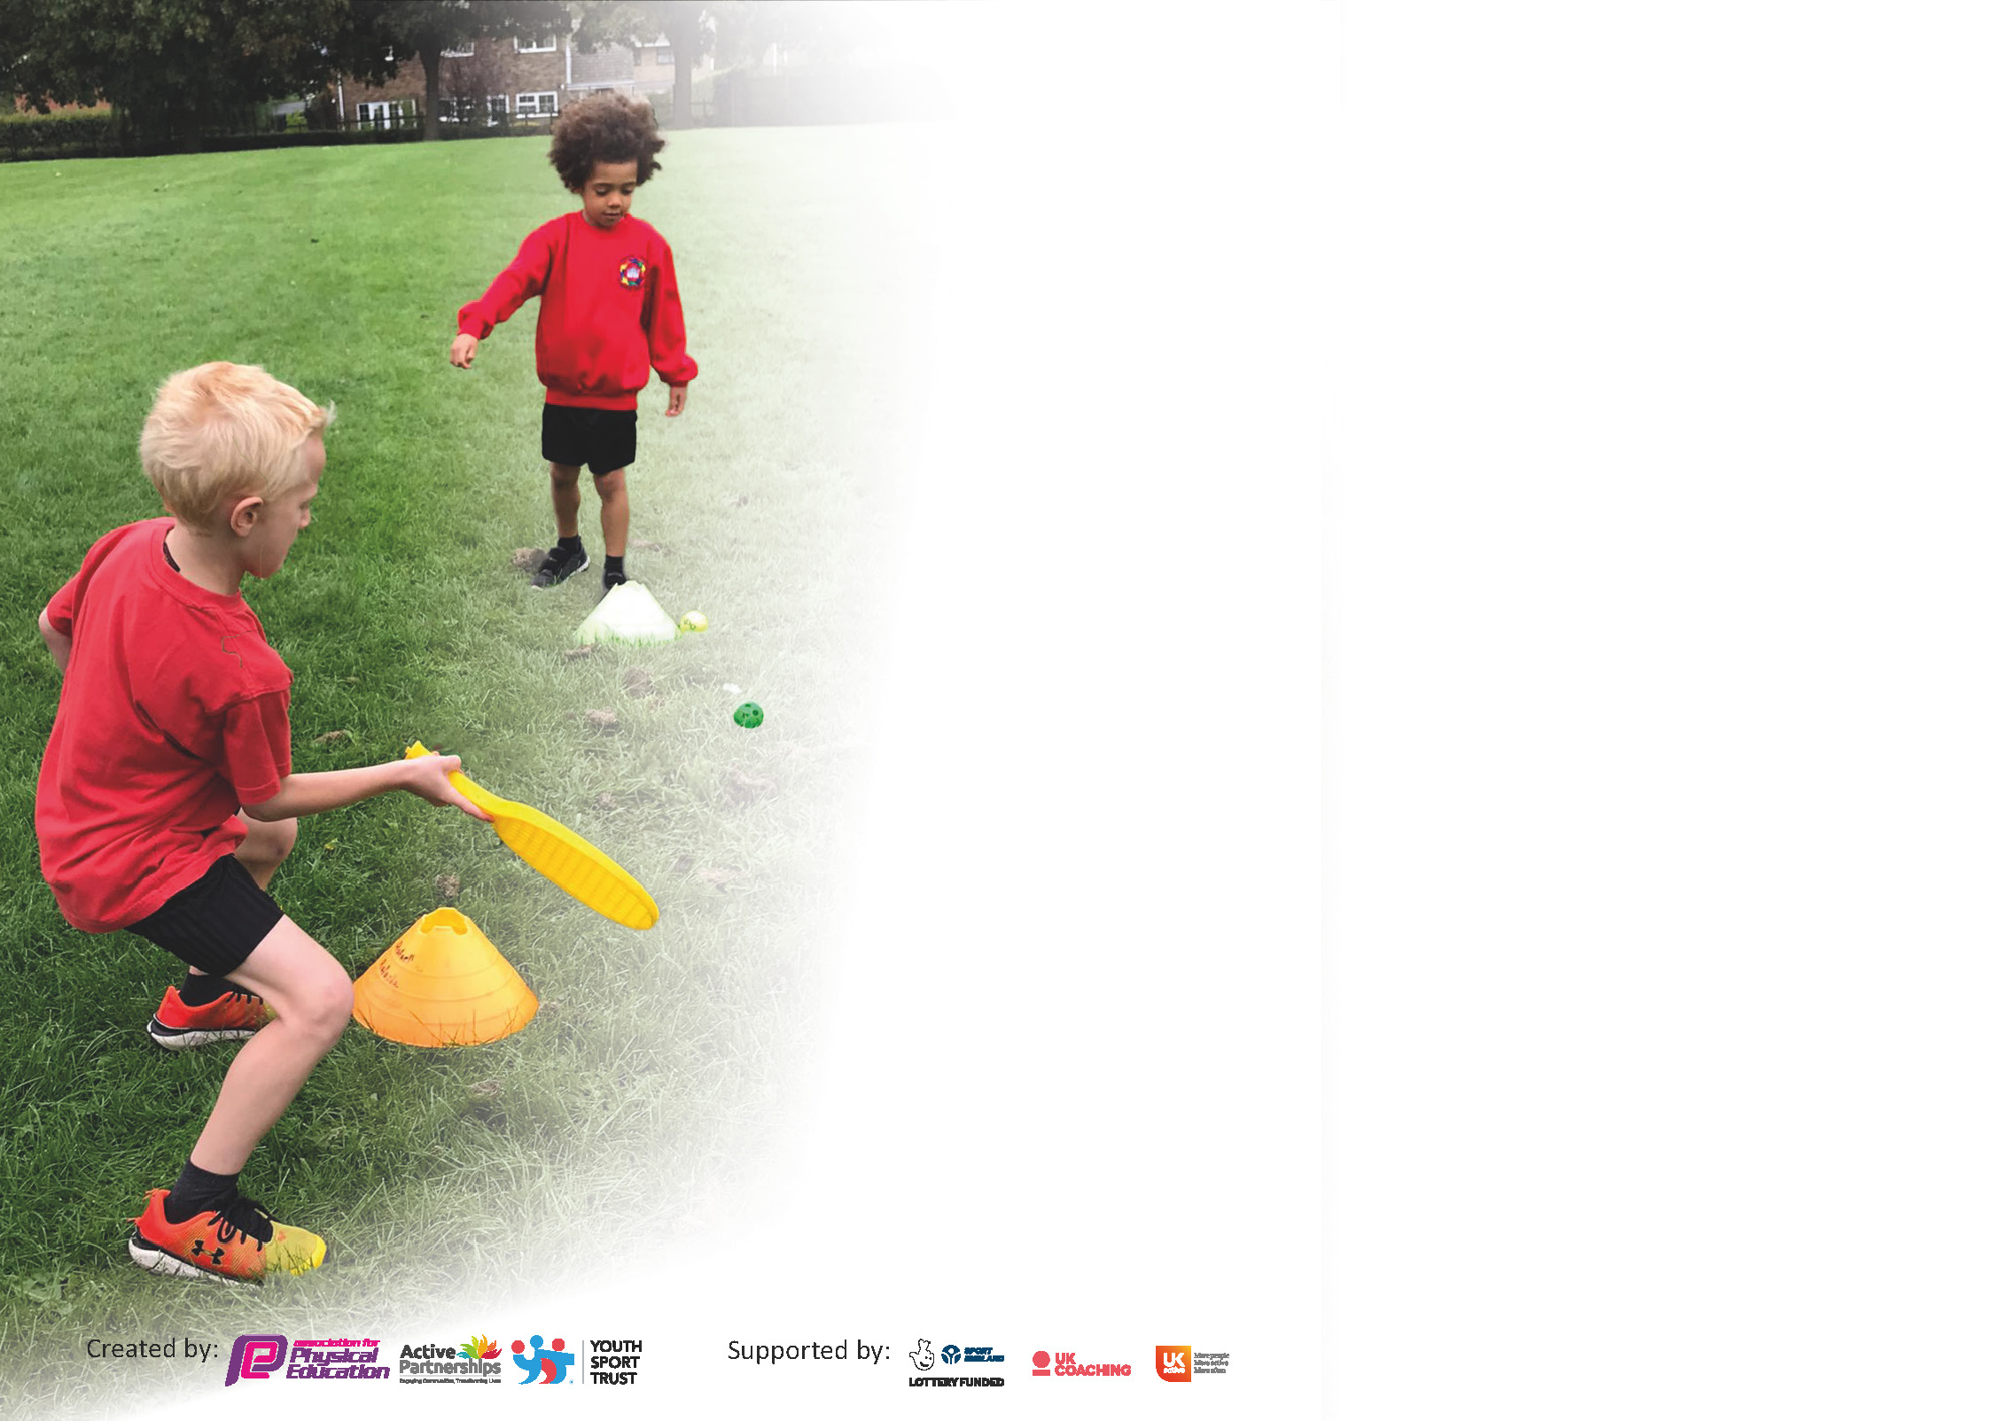

It is important that your grant is used effectively and based on school need. The Education Inspection Framework (Ofsted 2019 p64) makes clear there will be a focus on ‘whether leaders and those responsible for governors all understand their respective roles and perform these in a way that enhances the effectiveness of the school’.

Under the Quality of Education criteria (p41) inspectors consider the extent to which schools can articulate their curriculum (INTENT), construct their curriculum (IMPLEMENTATION) and demonstrate the outcomes which result (IMPACT).

To assist schools with common transferable language this template has been developed to utilise the same three headings which should make your plans easily transferable between working documents.

Schools must use the funding to make additional and sustainable improvements to the quality of Physical Education, School Sport and Physical Activity (PESSPA) they offer. This means that you should use
the Primary PE and sport premium to:

- Develop or add to the PESSPA activities that your school already offer
- Build capacity and capability within the school to ensure that improvements made now will benefit pupils joining the school in future years

Please visit gov.uk for the revised DfE guidance including the 5 key indicators across which schools should demonstrate an improvement. This document will help you to review your
provision and to report your spend. DfE encourages schools to use this template as an effective way of meeting the reporting requirements of the Primary PE and sport premium.

We recommend you start by reflecting on the impact of current provision and reviewing the previous spend.

Schools are required to publish details of how they spend this funding as well as on the impact it has on pupils’ PE and sport participation and attainment by the end of the summer term or by 31st July 2021 at the latest.

** In the case of any under-spend from 2019/20 which has been carried over this must be used and published by 31st March 2021.

We recommend regularly updating the table and publishing it on your website throughout the year. This evidences your ongoing self-evaluation of how you are using the funding to secure maximum, sustainable impact. Final copy must
be posted on your website by the end of the academic year and no later than the 31st July 2021. To see an example of how to complete the table please click HERE.
Created by: Supported by:

Please note: Although there has been considerable disruption in 2020 it is important that you publish details on your website of how you spend the funding - this is a legal requirement.
Support for review and reflection - considering the 5 key indicators from DfE, what development needs are a priority for your setting and your pupils now and why? Use the space below to reflect on previous spend and key achievements and areas for development.

N.B. In this section you should refer to any adjustments you might have made due to Covid-19 and how these will influence further improvement.
Key achievements to date until July 2020: | Areas for further improvement and baseline evidence of need:
- Children continue to consistently receive high quality modern PE lessons. Lessons are delivered by confident, level 5 PE qualified, staff using a wide variety of great resources. Lessons observed deemed to be of a high standard, exciting and challenging for the children.  - During a latest OFSTED visit, PE was observed (deep dive). They reported PE to be lively and interesting. They felt that the subject area was covered well and in a sensible progressive order. They observed the children enjoying their PE and saw them making strong progress.  - We placed a larger focus on ‘values’ this academic year. Link to the DFE, Emneth Academy, EMAT and School Games visions, values and foundations. Our values are proudly displayed in the school hall and linked to every PE lesson.  - 30, Y5 children have completed the SSP Young Leaders course this academic year, they are now ready to run successful activities and games during lunchtimes across both key stages (after restrictions are lifted). 20 more children will complete the training next academic year.  - Children continue to be active at break and lunch times and behaviour continues to improve. We have replaced and improved our trim trail and added a fitness trail to the playground to ensure we meet the government requirement of the addition 30 mins of daily exercise/activity.  - Children continue to become more confident and competitive. Inter class competitions have been vital this academic year. We have run, curling, cross country, athletics and ‘most active’ events.  - We continue to forge link between ourselves, our families and the local community, particularly Grange Farm Swim School, Premier Sport, SSP, EMAT and WGS.  - Pupil Voice data (April 2021) shows that our children are really happy in their PE sessions. They find their PE lessons exciting and challenging, more understand how to make progress. Most are eager to represent EA in competitions and events.  - We participated in various SSP Virtual Sports Challenges and events during and after lockdown. Over 80 % of our children participated in various virtual events this academic year.  - We recently participated in an EMAT Trust Athletics event, every child in school participated in this event.  - We continue to broaden and develop the sports and activities that we offer in school and within the local community. We’ve introduced the children to Curling, Tri Golf and Lacrosse this academic year.  - Personal challenges have been a huge success this academic year. The children have completed eight personal challenges this academic year. | - Continue to closely monitor the DFE School Sports & Activity Action Plan, ensuring we continue to implementing required actions and changes.  - Continue to make children and parents more aware of the 60 mins addition physical activity aim and recognise its importance.  - CPD opportunities for TAs – focus on swimming, forest schools and level 3 NPECTS.  - Look at the possibility of increasing active travelling to and from school. Link to Walk/ Bike to School week – May 2022. Possible Link to Bikability and Cycling Proficiency  - Restart, provide and develop extra-curricular clubs to increase participation further (our school aim for this academic year is 80% across both key stages by the end of 2022) – More equipment and high quality out door agencies required to facilitate this.  - Continue to improve and support PE leadership at Emneth. Improve face to face connections with PE subject leaders across EMAT and Cluster when restrictions are lifted.  - Continue to broaden and develop the sports and activities that we offer in school and within the local community –with a focus on Cricket and Rugby, next academic year.  - Continue to raise sporting aspirations & the profile of PE across the school. Keep up the momentum and high expectations ethos.  - Continue to invest in good lunchtime provision and activity organisation. Play leader course booked again for Sept 2022. A wider range of activities planned – more equipment and play leaders needed to facilitate this. Add in another ‘personal challenge’ opportunity area to meet sports mark requirements.  - Ensure that all Y6 children can competently swim at least 25m. Organise addition top up swimming sessions, if required.  - Ensure we gather the evidence needed to meet the requirements to achieve the School Games Gold Sports Mark 21/22  - Participate and organise SSP, WGS and cluster competitions and festivals. Only virtual events attended this academic year due to Covid.

Did you carry forward an underspend from 2019-20 academic year into the current academic year? YES

If any funding from the academic year 2019/20 has been carried over you MUST complete the following section. Any carried over funding MUST be spent by 31 March 2021.
Academic Year: September 2020 to March 2021 | Total fund carried over: £11675 | Date Updated: July 2021
What Key indicator(s) are you going to focus on?  Key indicator 1: The engagement of all pupils in regular physical activity  Key indicator 2: The profile of PESSPA being raised across the school as a tool for whole school improvement |  |  |  | Total Carry Over Funding:
 |  |  |  | £11675
Intent | Implementation |  | Impact
Your school focus should be clear how you want to impact on your pupils.  The children to take ownership of their lunch and playtime activities by setting and participating in various timed personal challenges.  Finish improving the trim trail, make it more challenging.  Add a double fitness trail to playground. | Make sure your actions to achieve are linked to your intentions:  Outdoor stopwatch purchased and used during playtimes, lunch and lessons.  Arranged for the trim trail company to compete the final elements. Timetable class usage for playtimes, lunch times and lessons.  Arranged for the trim trail company to compete the final elements. Timetable class usage for playtimes, lunch times and lessons. | Carry over funding allocated:  Large outdoor solar powered stopwatch on posts. £1645.00  Continue to fix and improve the trim trail (second stage) £7740.00  Added a fitness trail to the playground. £2390.00  £11775.00 spent | Evidence of impact: How can you measure the impact on your pupils; you may have focussed on the difference that PE, SS & PA have made to pupils’ re-engagement with school. What has changed?  Children regularly use the stopwatch during breaks and lunch time to provide them with timings of personal challenges set by themselves or by staff and playleaders.  The trim trail will continue to assist us in hitting the government target of 30 mins additional daily activity.  The fitness trail will assist us in hitting the government target of 30 mins additional daily activity. | Sustainability and suggested next steps and how does this link with the key indicators on which you are focussing this academic year?  Personal Challenges become embedded in school routine. Celebrate achievements and increase the number of personal challenges over the academic year.  Continue to and repair the equipment to ensure it remains usable. The trim trail becomes firmly embedded in school routine.  The fitness trail becomes firmly embedded in school routine. Links to personal challenges and inter class competitions.

Meeting national curriculum requirements for swimming and water safety.  N.B Complete this section to your best ability. For example you might have practised safe self-rescue techniques on dry land. | No swimming lessons this academic year due to Covid.
What percentage of your current Year 6 cohort swim competently, confidently and proficiently over a distance of at least 25 metres?  N.B. Even though your pupils may swim in another year please report on their attainment on leaving primary school at the end of the summer term 2021. | %68
What percentage of your current Year 6 cohort use a range of strokes effectively [for example, front crawl, backstroke and breaststroke]? | %68
What percentage of your current Year 6 cohort perform safe self-rescue in different water-based situations? | %68
Schools can choose to use the Primary PE and sport premium to provide additional provision for swimming but this must be for activity over and above the national curriculum requirements. Have you used it in this way? | No – Due to Covid

Due to Covid lockdown and restrictions, some of our 20/21 Sports Premium expenditure has not been carried out. This intended expenditure will be carried over to next academic year and spent in accordance with our academy PE action plan.
Action Plan and Budget Tracking
Capture your intended annual spend against the 5 key indicators. Clarify the success criteria and evidence of impact that you intend to measure to evaluate for pupils today and for the future.

Academic Year: 2020/21 | Total fund allocated: £17750,00  Plus last year’s under spend. | Date Updated: July 2021
Key indicator 1: The engagement of all pupils in regular physical activity – Chief Medical Officers guidelines recommend that primary school pupils undertake at least 30 minutes of physical activity a day in school |  |  |  | Percentage of total allocation:
 |  |  |  | %
Intent | Implementation |  | Impact | TBC
Your school focus should be clear what you want the pupils to know and be able to do and about  what they need to learn and to  consolidate through practice: | Make sure your actions to achieve are linked to your intentions: | Funding allocated: | Evidence of impact: what do pupils now know and what can they now do? What has changed? | Sustainability and suggested next steps:
Ensure that we continue to offer a wider range of easily accessible extra-curricular activities.  Ensure that they are available daily for children to access.  Continue to improve provision for physical activity at lunchtime. Increase the amount of resources and organised activities available.  Continue to give the children the opportunities to participate in personal challenges. Use Sportshall Athletics style activities to encourage personal challenges.  Continue to fix and improve the trim trail (final stage).  Add a fitness trail to the playground.  Highlight Active travelling.  Purchase Moki fitness/activity bands | Purchased specialist equipment and teaching resources to support extra -curricular activities and lunch time activities.  Performed regular safety checks on this equipment.  Asked the children what type of clubs they would lie to attend. Offer clubs at different times of the day (lunch and after school) – Clubs affected by Covid Restrictions.  Use outdoor agencies to assist with the running of a wider variety of club. Affected by Covid restrictions.  Trained Year 6 play leaders continue to run a lunchtime activity schedule. Unable to implement this due to Covid Restrictions. Class play boxes to be introduced.  Ask Staff to run personal challenges once a week. Different challenges every half term. Monitor participation and continue to target the less active.  Companies to design and quote for replacement trim trail pieces. Received quotes – work carried out Oct 2021  Companies to quote for the fitness trail. Received quotes – work carried out Oct 2021  Set a family travel to school challenge during sports week. Link to Cycling to Walking Investment Strategy. Postponed due to Covid 19  Use the Moki bands and software to identify the children who are meeting the addition 30 mins gov target. | Safety Checks  £60.00  Play box equipment  £100.00  Playleaders Course £250.00  Large Outside Stopwatch  £1645.00 (paid for by last year’s under spend)  Trim trail  £7740.00 (paid for by last years under spend)  Fitness trail  £2390.00 (paid for by last year’s under spend)  TBC  £705.00 | We should have had increased pupil participation across both key stages in extracurricular activities during and after school – our school aim was 80% by the end of 2021 academic year. Clubs and activities unable to run due to Covid restrictions. Target carried forward to 2022  We aim to offer an enhanced, exciting, extra-curricular program.  Increased school community links.  A wider variety of extra-curricular clubs should have been available. Unable to run due to Covid restrictions.  Our Covid safe class play boxes help encourage improved behaviour and attendance, we’ve seen a reduction of low-level disruption during lunchtime.  Positive impact on whole school, linking to core values. Half Termly Activity timetable for lunchtime provision replace with Covid Safe play boxes.  An increase in the number of children challenging themselves and recognising and celebrating their personal improvement and progress.  Personal Challenges are a favourite at lunch time.  The trim trail will continue to assist us in hitting the government target of 30 mins additional daily activity.  The playground will assist us in hitting the government target of 30 mins additional daily activity.  The playground will continue be used more effectively. Highlights the requirement of an additional 30 mins of physical activity and its importance.  Postponed due to Covid restrictions.  Use the Moki data to identify those that need support to meet the 30 min target. | Continued increased links with local clubs. Continue to liaise with pupils to ascertain the clubs and activities the pupils want to attend this should lead to further increase in participation and a positive attitude to health and wellbeing.  Staff continue to be  keen to keen to run wider variety of extra-curricular clubs when allowed  .  SSP Play leader training already booked for the next group of play leaders.  Possible TA training to continue to support and oversee lunchtime provision.  Personal Challenges becomes embedded in school routine. Celebrate achievements and increase the number of personal challenges over the academic year.  Continue to replace and repair the equipment to ensure it remains usable.  Continue to monitor the playground to ensure it remains usable.  Link to bike ability and Youth Charter. Postponed due to Covid 19.  Continue to monitor and track activity data to ensure we are giving the children enough opportunities to meet 30 min target.
Key indicator 2: The profile of PESSPA being raised across the school as a tool for whole school improvement |  |  |  | Percentage of total allocation:
 |  |  |  | %
Intent | Implementation |  | Impact | TBC
Your school focus should be clear what you want the pupils to know and be able to do and about  what they need to learn and to  consolidate through practice: | Make sure your actions to achieve are linked to your intentions: | Funding allocated: | Evidence of impact: what do pupils now know and what can they now do? What has changed? | Sustainability and suggested next steps:
Continue to share sports news and information with parents, to raise the profile of PE.  Hold assemblies to celebrate achievements and ensure the whole school are aware of the importance of PE and celebrate participation and success.  No whole school assemblies held due to restrictions.  Sporting Notice Boards and sporting timeline sharing sporting information for all visitors, children and parents.  Post personal challenges and family physical activities on Class Dojo during lockdown  Continue to celebrate our children’s sporting achievements (in and out of school) through newsletters, social media, press, Class Dojo and website.  Hold our annual Sports Day.  Continue to fix and improve the trim trail. (See section 1 for more info)  Reaffirm our AFPE membership and continue working towards achieving the Gold Sports Mark. | Sporting info shared on school newsletters, our school Facebook and twitter accounts, through the press and on our school website and Class Dojo.  Opportunities during assemblies to share sports news and success throughout the whole academic year.  NO whole school assemblies due to DFE restrictions.  Ensure exciting sport themed notice boards are up to date and easily accessible by children, staff and parents  Add differentiated weekly challenges onto each Class Dojo for children and families to complete during lockdown.  Monitor participation.  We share a sporting timeline board in a prime position where we can share their sporting achievements. Sports news is also shared regularly on the school newsletter and social media pages.  Hold KS1 and KS2 Sports Days. Children encouraged to participate in various sports day races.  Companies to design and quote for replacement trim trail pieces. Pay yearly subscription.  Gather evidence needed against the criteria in preparation for the application and highlight any missing pieces of information. No awards given this year due to Covid | Wall Display Equipment  £40.00  Certificates and trophies - £50.00  Line marking machine and liquid £479.97  See section 1  £95.00 | Parents are more involved and aware; they participated in several lockdown family challenges. They now understand our Sports ethos and values and offer support when needed.  Sports news shared on school newsletter and social media pages.  All pupils to take part in an assembly. Pupils are proud to be involved in sports assemblies and celebrate their achievements. T  NO whole school assemblies due to DFE restrictions.  The notice boards are full of current information about School Games, competition and results, local clubs, personal challenges and the importance of 60 mins physical acti.  Pupils are now keen to get involved and try new things.  We ensure the children share, recognise and celebrate their sporting success. This increased self-esteem and confidence and has an impact across the whole curriculum. More and more children are proud to share news!  Continue to celebrate sport at Emneth to highlight its importance.  All children competed in a positive and fun setting This increased enthusiasm and shared a positive message and raised the profile.  The trim trail will assist us in hitting the government target of 30 mins additional daily activity.  National recognition celebrates success. A fantastic self-review and evaluation tool. A way to recognise best practice. We aim to achieved the SSP West Norfolk Gold award in 21/22. | Continue to embed the importance of PE and physical activity and celebrate this with parents to ensure that PE and sports are central to the lives of the pupils.  Premier Sports to continue to come in to share information and well-being sessions.  News and photos on PE notice boards etc. This is impacting awareness and we continue to see an increase in confidence and self-esteem.  The children and staff continue to celebrate their sporting achievement and strive for continued success and recognition.  This will help us continue to increase physical literacy.  Continue to work together with parents to embed the importance of PE and physical activity in our school daily life.  Keep the momentum going with more exciting family involved events – family PE lessons, and family wellbeing/family PE cafe events are planned for the future.  Continue to replace and repair the equipment to ensure it remains usable.  Apply for the sports mark during 21/22 and try and improve and gain a Gold award.

Key indicator 3: Increased confidence, knowledge and skills of all staff in teaching PE and sport |  |  |  | Percentage of total allocation:
 |  |  |  | %
Intent | Implementation |  | Impact | TBC
Your school focus should be clear | Make sure your actions to | Funding | Evidence of impact: what do | Sustainability and suggested
what you want the pupils to know | achieve are linked to your | allocated: | pupils now know and what | next steps:
and be able to do and about | intentions: |  | can they now do? What has
what they need to learn and to |  |  | changed?
consolidate through practice:
Continue to pay a yearly subscription to PE Passport (an interactive PE curriculum,) to support the overall delivery and consistency of the PE provision.  PE Lead to support Class Teacher’s  teaching PE.  Continue to improve PE Subject Leadership  Continue to invest in an effective assessment tool/program to ensure that we accurately assess, track, record and measure progress.  Continue to monitor progress and achievement of all pupils.  Purchase a bank of ipods to improve feedback.  CPD for TA who supports PE and Swimming  CPD for TA’s support for Forest Schools. | Continue to pay a yearly subscription to PE Passport, payment due Oct 2020.  Lesson obs, PE passport planning  shared half termly discussions  and assessments.  Attend Staff meetings with a focus on subject leadership. Meetings with other PE leads termly (Cluster, EMAT and WGS).  Subject Leader/ Staff to visit other schools with the cluster/trust to observe good practice. – Postponed due to Covid. Teams meetings held instead.  Quality of resources for lessons purchased to allow for outstanding physical education and pupil attainment.  Re organisation of the PE cupboard  PE subject leader to provide updates throughout the year to SLT.  PE subject leader to meet with a broad range of pupils to talk about their PE lessons and to ascertain their knowledge and understanding of the subject as well as their opinions of PE at Emneth Academy (pupil voice).  PE Lead and staff to complete relevant online training and courses. PE Leadership time to carry out above requirements.  PE Passport – as above Unit assessment provided every half term and children tracked/monitored continuously.  Use Ipods during lessons to promote high quality immediate feedback by using video and photos to support.  Courses postponed due to Covid restrictions.  Courses postponed due to Covid restrictions. | PE Passport £325.00  Replacement Equipment  £160.65  Sports cupboard re-organisation  £1100.95  PE Passport  £999.00  T.B.C  T.B.C | PE passport ensure consistency across both key stages, it eliminates gaps and record and tracks evidence and progress effectively. PE teacher can now quickly assess and monitor progress and PE lead can now track levels of participation. PE Passport planning ensures continuity, sequence of learning and coverage.  Increased confidence and better  subject knowledge for Class  teacher. PE Passport planning  ensures continuity and coverage.  Attend staff meetings to ensure the role of PE lead is being completed to a high standard.  Share ideas and forge links, continue to improve and develop as part of a wider community.  New/different equipment will continue encourage curiosity, fun and enthusiasm.  This will enable staff easier access to all equipment. Equipment can be stored safely and avoid breakages due to poor storage.  Subject leadership time to complete RA, AFPR Reports. Keep the SLT up to date with Sports in Emneth Academy Look closely at questionnaire, correlate findings.  PE continues to be a subject that is recognised, understood, led and managed very well. Subject leader evidence is thorough and invaluable with regard to next steps and moving forward.  Lots of online CPD training carried out during lockdown 2021.  An increased knowledge of each and every pupil (year on year). An increased amount of evidence available to support findings and results.  Children are giving much better, high quality feedback now, by using the photos and videos taken to support and help explain.  More people will be able to facilitate PE and Swimming requirements to a high standard | Staff will continue to be confident and delivering outstanding, exciting PE lessons.  PE leader can continue to up  skill staff in school and across  the trust when the funding  stops  PE Subject leader/staff to meet with colleagues at other schools to encourage on going sharing of good PE practice across schools  Continued CPD can come from sharing good practice in school and working with other schools within the community.  Keep a record of equipment to ensure we replace any broken equipment before it is needed.  As above.  PE Subject Leader to monitor and to provide support as appropriate in order to ensure good progress and achievement are maintained by all pupils.  Continue to offer new, exciting, challenging activities for our children to confidently try. Implement new post Covid lesson ideas.  Staff continue to be able to track efficiently and highlight those children needing extra support.  This method of feedback continues to help with AFL and stronger peer feedback across the school, particularly in KS2.  An continued increase in available staff and staff confidence and knowledge
Key indicator 4: Broader experience of a range of sports and activities offered to all pupils |  |  |  | Percentage of total allocation:
 |  |  |  | %
Intent | Implementation |  | Impact | TBC
Your school focus should be clear | Make sure your actions to | Funding | Evidence of impact: what do | Sustainability and suggested
what you want the pupils to know | achieve are linked to your | allocated: | pupils now know and what | next steps:
and be able to do and about | intentions: |  | can they now do? What has
what they need to learn and to |  |  | changed?
consolidate through practice:
Additional achievements:  Continue to offer a wider range of sporting activities within the curriculum, school and local community to get more children involved, particularly those children who do take up additional PE and sport opportunities. Increase the number/variety of extracurricular activities offered at Emneth Academy. With a focus on  • Inclusion  • The promotion of active, healthy lifestyles.  • Quality, qualifications and talent of staff providing the activity.  • A wider choice of time of day when activities are offered.  • Pupil needs/interests (Pupil Voice)  Introduce the children to new sports. | Planned Top 20 sporting activities for this year were –  • Sporting event – Ice Hockey postponed due to Covid 19  • Horsey Fun - postponed due to Covid 19  • Wet and Wild - postponed due to Covid 19  • Whole school Sport Week Launch event postponed due to Covid 19  • Dance Performance and Xmas Dance Show - postponed due to Covid 19  Continue to reinvest in SSP sporting opportunities – Active kids, Young Leaders and OMNES Games  Purchase the equipment required to implement new exciting sports into the curriculum.  Look at improved/new after school club availability.  Employ more coaches - to provide extra-curricular sporting opportunities.  Focus on Lacrosse, Curling, Cricket and Tri Golf | SSP – Active Kids, OMNES Games, Happy, Healthy, Active.  £1175.00  New Sports  Tri Golf  £250.00  Lacrosse  £190.00  Curling  £336.00 | Continue to give the children the opportunity to experience sport’s physical activities that are different to the regular sports taught with the school setting.  Increased all pupil participation in events, activities, competitions, festivals and clubs.  An enhanced, exciting, extra-curricular program offering new sports and activities.  Improved behaviour and attendance and reduction of low-level disruption during lunchtime due to play leader led activities.  Positive impact on the whole school. The children now try and enjoy various new sports confidently and without hesitation. This leads to increased school-community links (WGS, Cluster, SSP, EMAT). | Continue to raise sporting aspirations and interests. Continue with the OMNES Games next year, this have been a great way to engage pupils who may not participate in regular sport.  Continue to increase links with local sports clubs. This will ensure a further increase in participation.  A Positive attitude to health and well-being and trying something new!  The staff are more confident and keener to run different extra-curricular clubs.  More children are now able and want to try new sports. We’re removing barriers and increasing opportunities.

Key indicator 5: Increased participation in competitive sport |  |  |  | Percentage of total allocation:
 |  |  |  | %
Intent | Implementation |  | Impact | TBC
Your school focus should be clear | Make sure your actions to | Funding | Evidence of impact: what do | Sustainability and suggested
what you want the pupils to know | achieve are linked to your | allocated: | pupils now know and what | next steps:
and be able to do and about | intentions: |  | can they now do? What has
what they need to learn and to |  |  | changed:
consolidate through practice:
Continue to hold termly inter class competitions to engage all pupils across both key stages. Virtual only this academic year.  Continue to host and attend Cluster and Trust competitions across KS1 and KS2 this academic year. Continue to attend SSP & WGS sporting events this academic year. Virtual events only attended due to Covid restrictions.  Ensure that our SEND and PP children are given opportunities to compete in competitions. Virtual events only attended due to Covid restrictions. | Hold termly tournament between classes/year groups. Both key stages to participate in fun but challenges events. Link to core values.  Events held this academic year included – personal challenge, escape room, the cube, cross country, class participation and curling.  Attended and host events and competitions. Virtual events only attended due to Covid restrictions.  Released staff to attend and organise transport. Virtual events only attended due to Covid restrictions.  Attend all SSP competitions (level 3 and level 4) and WGS competitions. Release staff to attend, organise transport. Virtual events only attended due to Covid restrictions.  Competition equipment to be purchased. Virtual events only attended due to Covid.  Ensure that all Y5/Y6 to attend at least one competition/festival this academic year. Virtual events only attended due to Covid restrictions.  Take our KS1 SEND/PP children to the West Norfolk Active Kids events three times during the academic year.  Virtual events only attended due to Covid restrictions. |  | Children and staff are regularly engaging in fun competitions. All children are included and participate.  Continue to Improve links with other schools within our cluster/ trust/ SSP and local community. Celebrate success. Virtual only this year.  Events regularly hosted and attended. Virtual events only attended due to Covid restrictions.  Improved, consistent results.  Virtual events only attended due to Covid restrictions.  Continue to forge strong links with other schools and sporting clubs within our community.  Boost confidents and encourage ALL to try new things and celebrate success. | Competitions once again, to become embedded in school life.  Increase the number of KS1 competitions/festival planned for next year.  Positive attitude towards winning and losing.  Compete again next year to try and retain our titles or improve on previous performances and results.  Continue to be inclusive and continue to increase the opportunities for participation.

Signed off by
Head Teacher: | Mr B. Rimmer 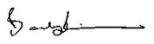
Date: | July 2021
Subject Leader: | Lynsey Skate
Date: | July 2021
Governor:
Date:

