Emneth Plan for opening – March 8th Opening 2021

Entering the school

There are staggered starts to ensure that children do not ‘bottle neck’ when entering the school site. The times are below:
Year group | Start time | Where entering
Reception | 8.40 am | Main entrance – then right side
Year 1 | 8.40 am | Second entrance – small gate
Year 2 | 8.40 am | Second entrance – main gate
Year 3 | 8.50 am | Second entrance – main gate
Year 4 | 8.50 am | Second entrance – small gate
Year 5 | 8.50 am | Normal entrance – fire exit by year 6 class
Year 6 | 8.40 am | Normal entrance – fire exit by year 6 class

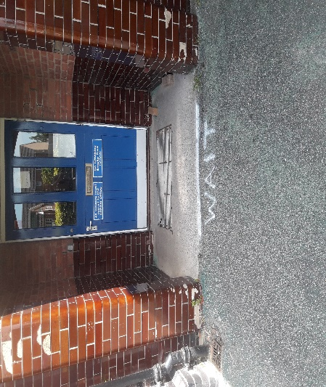
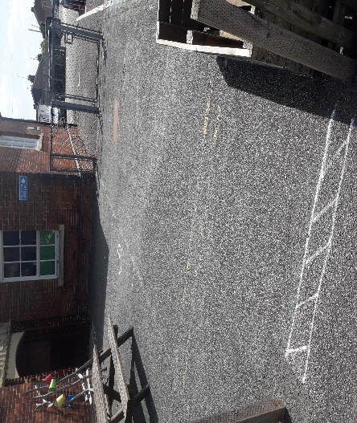
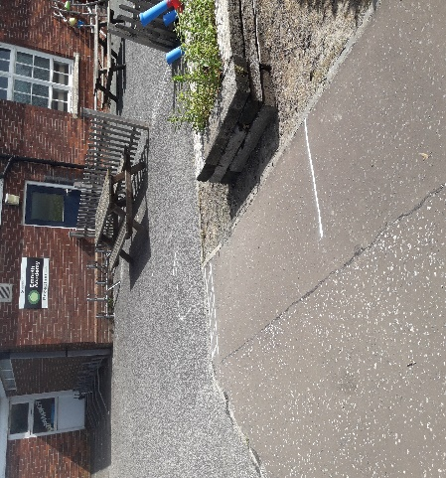
Year 5 & 6 children and parents will line up along the front fence and enter through the normal entrance. They will then enter the through the fire exit into the Year 6 building.
- Lining up (2) Lining up & staff to meet here (3) Entrance into building
There are distinct markings to show the correct 2m spacing as parents and children wait to come into school. They will be met by a member of staff from their class. When they are in the building, children will either wash their hands or use sanitising gel provided by the staff.
Reception children will come through the main gate entrance. There will be markings to show distancing –parents and children need to adhere to these markings. Parent and child must wait at the lines.
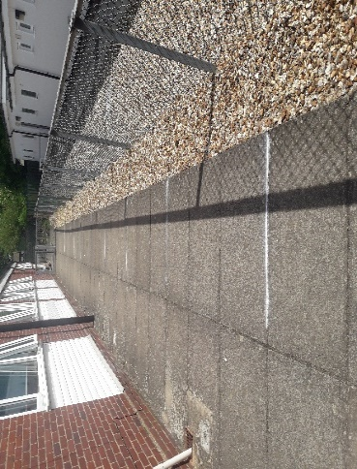
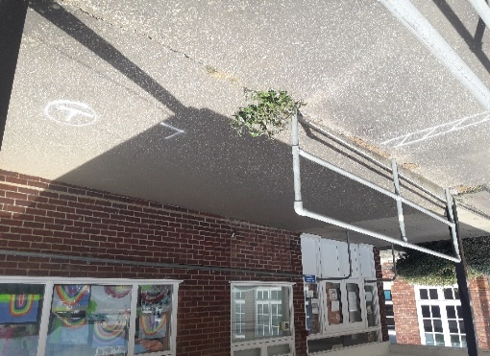
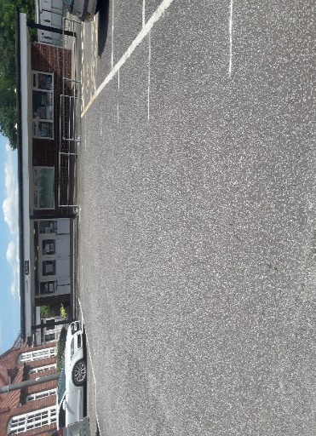
Then a member of staff will ask them to enter the building and wash their hands. The photos below show the key: (1) Lines for reception - main entrance (2) Entrance to the right of the main (3) Lining up for reception

Year 1, 2, 3 & 4 children will come through the entrance to the second car park/playground entrance. There will be distinct markings that the child must follow for social distancing.
The year 1 & 4 children will then be admitted into school through the side entrance, where they will be wait until called to wash their hands before going into class.
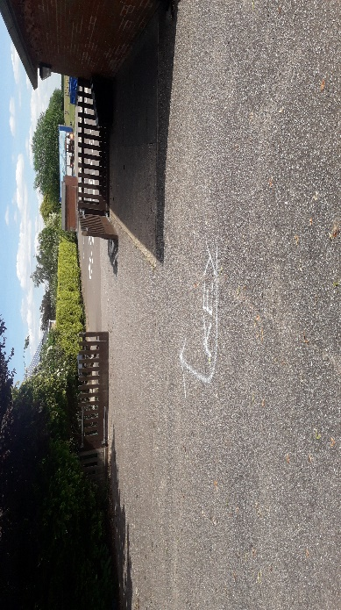
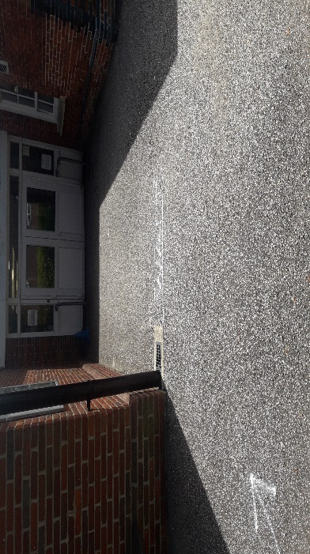
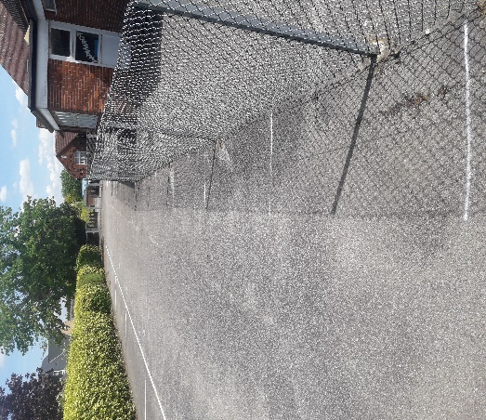
The year 2 will make their way onto the playground, where they will meet a member of staff. Here they will wait and then be called into wash their hands.
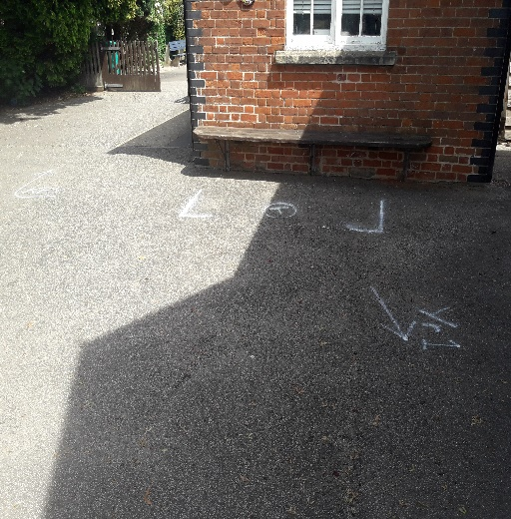
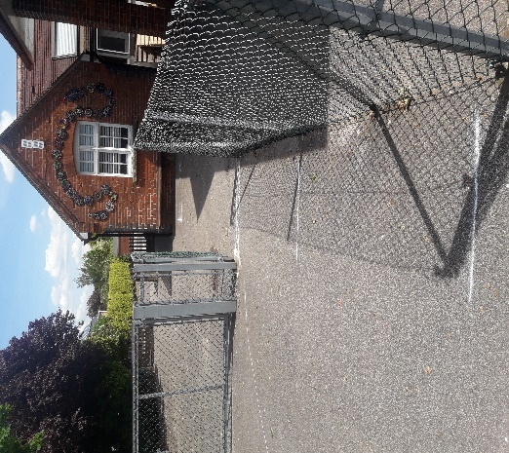
- Lining up for Yr 1, 2, 3 & 4 (2) Small gate for Yr 1 & 4 (3) Large gate for Yr 2 & 3

(4) Staff to meet Yr 1 & 4 children here (5) Staff to meet Yr 2 & 3 children here.

Leaving the school.

There will also be staggered finished to the day. This is to ensure that children leave the site safely and give staff the opportunity to prep for the next day.
Year group | Start time | Where leaving
Reception | 3.05 pm | Main entrance – then right side
Year 1 | 3.05 pm | Second entrance – small gate
Year 2 | 3.05 pm | Second entrance – main gate
Year 3 | 3.15 pm | Second entrance – main gate
Year 4 | 3.15 pm | Second entrance – small gate
Year 5 | 3.15 pm | Normal entrance – fire exit by year 6 class
Year 6 | 3.05 pm | Normal entrance – fire exit by year 6 class

The route out of school will be the same for the children as for entering the building – only in reverse. Parents will line up and wait. The children will then wait to be dismissed by the members of staff. Parents and children will then follow the arrows out of the school site, maintaining social distancing.

Staff entering & leaving the site.

Staff will need to enter the site through the normal entrance. They will need to sanitise/wash hands on the way into school before signing in. This will need to happen on the way out of school too.
Staff in each area will have PPE (if needed) and sanitiser.

Classroom and staff allocation.

The class teachers and support staff will be the same as the current structure. Children will not be able to go into another class (class bubble), however staff may go into another bubble. This supports staff being used for PPA cover, PE lessons and also teaching assistants being able to support children in other classes.
Reception – will be manned as previous academic year.

Classroom practice.

The classrooms have been set out to ensure that there is appropriate distancing from each other. Tables will be in lines facing the front and staff should maintain a safe distance at all times.
The reception class is set out differently to the other classrooms, however the door to the outside area is open at all times to allow for free flow opportunities for learning which enable children to work at a safe distance.
Any 1:1 closer work with a child can be no longer than 15 minutes. Each child will have the following provided by the school:
- Pen and pencil.
- Stationary e.g. rulers.
- Dictionary (if needed).
- Rubber, highlighter.
Doors and windows will be open to allow for good ventilation through the classrooms.
*Each child will have a tray with these resources at their desk. Each tray will then be sanitised at the end of each week, including resources. The older children will be able to do this themselves – supervised from a distance by staff. Tables & chairs sanitised regularly.
For the next academic year, the learning in the classroom will focus on core skills and subjects to ensure that we start to fill any gaps in learning. There will be opportunities for the children to learn the wider curriculum during the week. Some of these opportunities may be part of their home learning tasks.

Break-time.

This will be staggered to ensure that all children have access to the playground and fresh air. There will be a staff duty rota in place as normal.
Time | Class
10.30 - 10.45 | Reception, Year 1 & Year 2
10.45 - 11.00 | Year 3, 4, 5 & 6

The playground will be split into 4 sections which will allow each class to have their own ‘bubble’ outside. If the weather is nice, this does give the potential to expand the area and use the field.
In the short term there will be no ball games allowed at break and the outdoor apparatus will be out of bounds.

Lunch-time.

Lunch times will be staggered to ensure that the class bubbles remain separate.
The lunch times will follow the normal timings from the previous year:
Time | Outside | Inside
12.00 – 12.30 pm | Yr 3, 4, 5 & 6 | Yr R, 1 & 2
12.30 – 1.00 pm | Yr R, 1 & 2 | Yr 3, 4, 5 & 6

Children with home packed lunch will eat their lunch in their classrooms during the allotted time. The hot meals will be delivered to the classrooms for years 2, 3, 4, 5 & 6. Reception and year 1 will eat in the hall where they will be separated at either end of the hall. The staff will take the meals to the tables. Staff will also ensure seats and tables are sanitised and wiped down after use.
Norse staff will ensure that they follow their own H&S guidelines.
This will ensure that the class bubbles remain separate from each other.
*At the end of any break or lunchtime, the children will need to be sent in to wash their hands/sanitise before entering the classroom/going outside.
There are sections in the playground for younger children – clouds spaced around the lower playground to support younger children distancing when outside. These will be clearly marked.
The children will have access to the grass area (weather permitting) – however they will not be able to play ball games or use the apparatus. Children will be told to follow distancing at all times by staff on duty.

Toilets.

There are allocated toilet areas for the classes – they must be the only toilets that they use. Again to ensure that the bubble is safe as possible. Please see below:
Group | Toilet allocation
Reception | Yr1/Reception girls.
Year 1 | Yr1/Reception boys.
Year 2 | Mobile toilet 1
Year 3 | Mobile toilet 2
Year 4 | KS2 toilets
Year 5 | KS2 toilets
Year 6 | KS2 toilets

It is up to each ‘bubble’ to ensure that toilets are used by children in an orderly fashion – i.e. 1 at a time. Staff will also need to ensure that children go to the toilet before each break or lunch-time, as when outside the toilets will be off limits as they won’t be able managed effectively.
*Toilets will need a regular spray at any break during the day. There will be spray bottles with disinfectant for each toilet area. This will help to manage hygiene in the toilet areas. A member of staff from each ‘bubble’ is to lead the spraying of this area.
Staff will use the toilet near to the hall, near reception and in the foyer – again there will be a spray bottle for staff to use regularly.
The water fountain will not be used – disconnected.

Cleaning.

As it states earlier in the plan, the children will have their own trays to keep resources in so that they can be cleaned at the end of the week.
Desks will need to be sprayed down and cleaned at specific points in the day e.g. before break, after lunch, at the end of the day.
Children will wash hands in the morning and it is important that the children wash their hands at regular intervals during the day (as per pre-lockdown).
There are spray bottles for the toilet areas that will be used in regular intervals to spray the sink areas. There is also sanitising gel that will be used by staff and/or children regularly.
When leaving the school children will need to wash/sanitise their hands at the testing zone.
Staff wearing PPE, if needed, will need to dispose of in black bin bags.
At the end of the day the school will be cleaned ready for the next day. Minimal surfaces will be used i.e. just desk space to allow for a more straight forward clean.

Ill children.

If a child has a temperature that is high or parents suspect a fever, then they should keep their child off school and contact the school straight away. Advice will be to organise a test as soon as possible. They will not be able to return to school for 10 days unless there is proof of a negative test result.
If a child displays symptoms during the school day, they must be isolated in an area with good ventilation and access to outside is nearby. A parent must pick up straight away and be advised that the child and family must isolate for 10 days. The whole class and teacher may also be isolated for 10 days – guidance does state to isolate only if the result of a test is positive, however the Academy will also take advice from both the NHS and Trust before making a final decision. If a class is isolated, then the classroom must undergo a deep clean within this time.
COVID room will be allocated for anyone with symptoms – ‘Thrive’ room is to be used.
Staff supervising any child with symptoms will need to wear full PPE and maintain a distance of at least 2m.

Administering first aid.

Any child that needs first aid e.g. any bumps or scrapes, the staff administering first aid must wear (at least) a face mask, gloves and an apron. If possible, when looking at a child, maintain a safe distance.
When the member of staff has finished, the PPE will need to be disposed of in a black bin liner.

Dress code.

The dress code for school is ‘normal uniform’ and the expectation will be that uniform is washed regularly to support minimising risk.
If PE is planned, then children will wear their PE kit to school that day. This will help to support minimising risk by removing the need to bring PE kit into school and having to change. Hats will need to be brought in if the weather is hot and sun-cream applied at home before school – this will not be able to be applied at school.

Other information.

Children will only be required to bring in the following into school:
- Reading bag (if appropriate).
- Reading book.
- Lunch box (if appropriate) & drinks bottle.
- Letter/permission slips. Although we will try to keep this to email and class dojo.

Laptops – if used by children, each child to have their own laptop – keyboards to be wiped down at the end of each day.
Expectations for behaviour will be as expected. Children will be made aware of the need to social distance and how to behave in the playground i.e. stay in their class bubble. Any child not meeting the expectations, parents will be contacted. *Please note – children will struggle with this and will forget! This relates to children who are blatantly ignoring members of staff.
There will be parental agreement sent out which they will need to sign/acknowledge receipt of. They will also receive an ‘abridged’ version of this planning document.
Any late arrivals will not be permitted through the normal school entrance for the class. They will have to go to reception and then wait for a member of staff from their bubble to collect them – after admitting all the children the site is designated as secure.
New additions to the guidance:
Face coverings in primary schools – face coverings should be worn by all staff and adult visitors in situations where social distancing between adults is not possible in communal areas and class rooms. The expectation also will be that all staff wear masks on the corridor when moving about school. As with the previous guidance, children in primary schools do not need to wear a face covering although can if they feel more comfortable doing so. For any close intervention, staff should wear masks and/or use protective screens on the desks.
Face visors or shields should not be worn as an alternative to face coverings. They may protect against droplet spread in specific circumstances but are unlikely to be effective in reducing aerosol transmission when used without an additional face covering. Some colleagues may feel more comfortable wearing a visor in class and this should be facilitated if necessary.
The guidance also covers the curriculum offer that schools must provide. For pupils in Key Stages 1 and 2, academies are expected to prioritise identifying gaps and re-establishing good progress in the essentials (phonics and reading, increasing vocabulary, writing and mathematics), identifying opportunities across the curriculum so they read widely, and developing their knowledge and vocabulary. You should ensure your curriculum offer remains broad, so that the majority of pupils are taught a full range of subjects over the year, including sciences, humanities, music and the arts, physical education and sport, religious education and, at Key Stage 2, languages.
B.Rimmer

